9

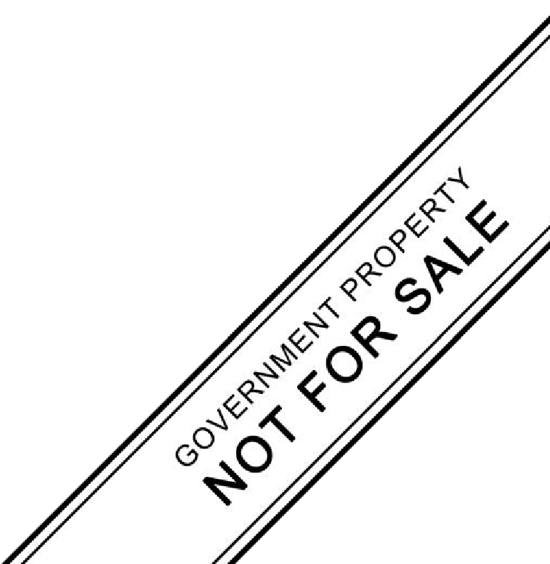

**DIVISION OF ANGELES CITY**

1

# MAPEH (HEALTH)

**Learning Activity Sheets**

Quarter 2

**DRUG SCENARIO IN THE PHILIPPINES**

**Name:**

## Section:

**Grade Level:**

**Date :**

## LET US KNOW (ALAMIN MO)

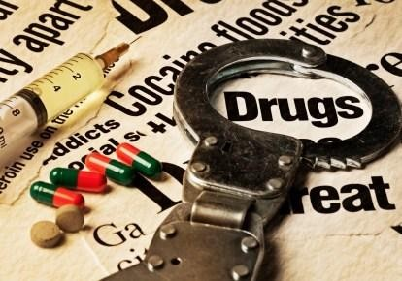In the Philippines, drug use and abuse is a prevalent problem. According to the Dangerous Drugs Board, there are 1.8 million current drug users in the Philippines and 4.8 million Filipinos report using drugs at least once in their lives. The most common type of substance use and abuse among Filipinos are: methamphetamine Hydrochloride (shabu), cannabis (marijuana) and inhalants.

The drug problem in the Philippines is one of the government’s major efforts in combating drugs and implementing a policy of criminalization and punishment. This is evidenced by the start of war on drugs under the government of Duterte that utilized measures to solve the problems on drugs.

This learning activity sheet provides knowledge from which you may gain more information about the common concepts in drug education and culminate your level of proficiency through the different assessment about the drug scenario in the Philippines.

Keep safe and enjoy learning!

## Learning Competency and Code

Describe the drug scenario in the Philippine ( H9S-lla-14)

 **LET US REVIEW (PAGBALIK-ARALAN MO)**

Let’s Try!

Direction: Find the words related to drug education in the puzzle and encircle them. Clues or descriptions are given below then write the correct answer on the space provided.

|  |  |  |  |  |  |  |  |  |  |  |  |  |  |
| --- | --- | --- | --- | --- | --- | --- | --- | --- | --- | --- | --- | --- | --- |
| **S** | **S** | **H** | **M** | **A** | **R** | **I** | **J** | **U** | **A** | **N** | **A** | **V** | **D** |
| **H** | **E** | **B** | **D** | **R** | **V** | **E** | **M** | **V** | **D** | **J** | **T** | **W** | **R** |
| **A** | **G** | **A** | **T** | **E** | **W** | **A** | **Y** | **D** | **R** | **U** | **G** | **S** | **U** |
| **B** | **K** | **D** | **G** | **M** | **X** | **F** | **N** | **W** | **E** | **K** | **T** | **X** | **G** |
| **U** | **I** | **G** | **U** | **E** | **Y** | **G** | **O** | **X** | **F** | **L** | **T** | **Y** | **T** |
| **E** | **N** | **D** | **R** | **U** | **G** | **M** | **I** | **S** | **U** | **S** | **E** | **Z** | **O** |
| **S** | **A** | **M** | **E** | **T** | **Z** | **H** | **P** | **Y** | **G** | **M** | **E** | **A** | **L** |
| **D** | **R** | **U** | **G** | **D** | **E** | **P** | **E** | **N** | **D** | **E** | **N** | **C** | **E** |
| **H** | **H** | **I** | **I** | **R** | **A** | **I** | **Q** | **Z** | **R** | **N** | **A** | **B** | **R** |
| **A** | **G** | **S** | **T** | **S** | **B** | **J** | **R** | **A** | **U** | **O** | **G** | **C** | **A** |
| **D** | **R** | **U** | **G** | **A** | **B** | **U** | **S** | **E** | **G** | **P** | **E** | **D** | **N** |
| **L** | **A** | **T** | **A** | **T** | **C** | **K** | **T** | **B** | **S** | **Q** | **R** | **E** | **C** |
| **I** | **C** | **O** | **B** | **U** | **D** | **L** | **U** | **C** | **H** | **R** | **S** | **F** | **E** |
| **I** | **N** | **H** | **A** | **L** | **A** | **N** | **T** | **S** | **I** | **S** | **U** | **G** | **H** |

1. Common abused drugs in the Philippines

2.

3.

4. Any substance when taken into the body have psychological, emotional and behavioural effects on a person.

5. The use of substance incoherent or inconsistent with the prescribed dosage or frequency of use.

6. The use of substance for non-medical purposes.

7. The condition of the body to adapt to the effects of substances to the body thus requiring even larger dosage or amount.

8. A phenomena in the body that creates a strong desire to take the substance.

9. Legal drugs that a non-drug user might try.

10. Most vulnerable in experimenting drugs.

 **LET US STUDY (PAG-ARALAN MO)**

## Common Concepts in Drug Education

The following are the usual words in studying substance use and abuse:

**Drugs** are any substances or chemicals which when taken into the body either through nasal, oral transdermal or intravenous ways have psychological, emotional, and behavioural effects on a person.

**Drugs of abuse** are drugs that are commonly abused by users.

**Drug dependence** is a cluster of physiological, behavioural and cognitive phenomena of variable intensity in which the use of a drug takes on a high priority thereby creating a strong desire to take the substance.

**Drug misuse** is the use of a substance incoherent or inconsistent with the prescribed dosage or frequency of use.

**Drug abuse** is the use of a substance for non-medicinal purposes. Abuse leads to organ damage like brain damage and liver damage, addiction and troubled behavioural patterns. **Drug tolerance** is the condition of the body to adapt to the effects of substances to the body thus requiring an even larger amount of the substance to experience the same physiological and mental effect experienced when taking the smaller dosage.

## You Must Also Know!

With the increasing problem of substance abuse in the country, there were laws enacted to strengthen and support the anti-drug campaign. There were agencies that monitor the strict regulations on possessions, manufacturing, sale and distribution.

**Republic Act No. 9165** also known as “**Comprehensive Dangerous Drugs Act of 2002**”. A policy of the state to safeguard the citizen from harmful effects of dangerous drugs.

**PDEA ( Philippine Drug Enforcement Agency**) the lead agency in the fight against illegal drugs and the implementing arm of the Dangerous Drugs Board.

**DDB ( Dangerous Drugs Board** ) leads the national advocacy against drug abuse.



## LET US PRACTICE (PAGSANAYAN MO)

**ACTIVITY NO. 1**

Answer the following questions. Write your answer on a sheet of paper.

1. From the common terms used in drug education, which among these have you observed in your community?
2. What is the current drug scenario in your community?
3. In your own opinion, how do the implementing agencies against illegal drugs can stop or eliminate the substance abuse in our country?

## LET US REMEMBER (TANDAAN MO)

**ACTIVITY NO. 2**

Summarize the ideas. Write your corresponding answer in a separate paper.

What is drug?

What are the most common abuse substances in the Philippines?

What are the common terms related to drugs?

## LET US APPRECIATE (ISAPUSO MO)

**ACTIVITY NO. 3**

What is RA 9165 all about?

Analyse the situation given and choose which is applicable from the common concept in drug education you have learned. Then justify or explain your answer on a sheet of paper

* 1. Rolando used a certain substance not for medication or illness in the body but for certain pleasure.

Explanation:

* 1. Everyday, you observe Benjo who is one of the street children that asked for alms, holding a small plastic and straw hidden inside his shirt and inhaling it every now and then.

Explanation:

* 1. Jessa use substance inconsistent with the prescribed dosage of the doctor.

Explanation:

* 1. Bob tried to use cigarettes in his teenage life, and then later on he tried the marijuana. Now, his body is not satisfied with the effects of those substances requiring larger amounts or dosage.

Explanation:

* 1. Julia cannot sleep without taking the pills in the night. Explanation:

## LET US PRACTICE MORE (GAWIN MO)

**ACTIVITY NO. 4**

Complete the necessary concepts on each term related to drug education. Write your answer on a piece of paper.

DRUGS

__

Drug Tolerance

Drug Dependence

Drugs of Abuse_

Drug Misuse

Drug Abuse

## REFLECTION

Answer the following questions. Use a separate paper for your answer.

1. Why do teenagers become the most vulnerable in experimenting drugs?
2. In the current drug scenario in your community or place, how can you help in combating the problems on illegal drugs?
3. What are the things that you can do to encourage your generation to avoid using

prohibited drugs?

1. Write a slogan or quote inside the box on how to help your community in combating the

prohibited drugs. Write your explanation below.

## References:

Physical Education and Health Learner’s Manual pages 270-273

## Image

[https://www.pursuits.com/drugs](http://www.pursuits.com/drugs-and-crime-is-there-a-close-relationship-bet/)-and-cri[me-is-there-a-close-relationship-bet/](http://www.pursuits.com/drugs-and-crime-is-there-a-close-relationship-bet/) **Nymia Simbulan, Leonardo Estacio and Melissa Wethers *Article: The Manila Declaration on the Drug Problem in the Philippines***

## Answer’s Key Let’s Try

1. Shabu 6. Drug abuse
2. Marijuana 7. Drug tolerance
3. Inhalants 8. Drug dependence
4. Drugs 9. Gateway drugs
5. Drug misuse 10. Teenagers

## Activity 2

1. Drugs are any substances or chemicals which when taken into the body either through nasal, oral transdermal or intravenous ways have psychological, emotional, and behavioural effects on a person.
2. Shabu, Marijuana and Inhalants
3. R.A 9165 “ Comprehensive Dangerous Drugs Act of 2002
4. Drug tolerance, drug abuse, drug of abuse, drug misuse, drug dependence Activity 3
5. Drug abuse 4. Drug tolerance
6. Drugs of abuse 5. Drug dependance
7. Drug misuse Activity 4
8. any substances or chemicals which when taken into the body either through nasal, oral transdermal or intravenous way have psychological, emotional, and behavioural effects on a person.
9. condition of the body to adapt to the effects of substances to the body thus requiring an even larger amount of the substance.
10. cluster of physiological, behavioural and cognitive phenomena of variable intensity in which the use of a drug takes on a high priority thereby creating a strong desire to take the substance.
11. drugs that are commonly abused by users.
12. use of a substance incoherent or inconsistent with the prescribed dosage or frequency of use.
13. use of a substance for non-medicinal purposes.

### *Prepared by:*

**JANETH S. HALILI**

SST III

Angeles City National High School

**THE RISK AND PROTECTIVE FACTORS OF USING DRUGS**

**Name:**

## Section:

**Grade Level:**

**Date :**

## LET US KNOW (ALAMIN MO)

It is greatly important to protect and prevent the youth from getting into drugs. There are risk factors that can lead to drug use. These factors can increase a person’s chances of abusing drugs or substances. There are also factors that may keep you away from drug use which are called protective factors. These factors can reduce the chances of drug or substance abuse.

According to studies, protective factors counterbalance negative effects of risk factors. It is important to understand that it does not necessarily mean that several risk factors present make a person highly susceptible to drug use, misuse, and abuse.

Learning Competency and Code

Discusses risk and protective factors in substance use, and abuse (H9S-llb-16)

 **LET US REVIEW (PAGBALIK-ARALAN MO)**

|  |  |  |
| --- | --- | --- |
| Drugs | Drugs of abuse | Drugs dependence |
| Drug misuse | Drugs abuse | Drugs tolerance |

Identify the following being described. Choose the correct answer from the box.

1. Refers to the use of substance for non-medical purposes.

2. They are drugs that are commonly abused by users.

3. It is a condition in which a person is accustomed to the drug that it relies on it to function normally.

4. It is the use of substance incoherent or inconsistent with the prescribed dosage or frequency of use.

5. They are substances or chemicals which when taken into the body have physiological, emotional and behavioral effects on a person.

6. It occurs when drugs consume continuously resulting in a reduction of their effects on the body

## LET US STUDY (PAG-ARALAN MO)

Domains in Life which Affect Drug use and Abuse.

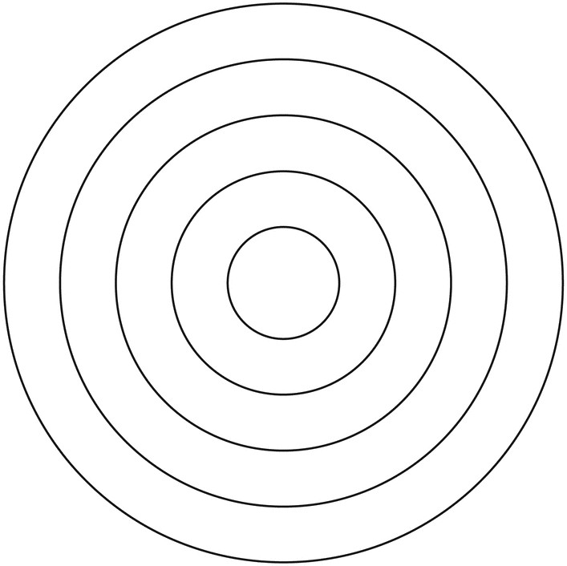

Community

School

Peer and friends

Family

Personal

RISK AND PROTECTIVE FACTORS IN THE USE, MISUSE, AND ABUSE OF DRUGS.

PERSONAL (Early Aggressive Behavior vs. Self-control)

 Risk Factors

* + Use of drugs at an early age
  + Risk taking behavior
  + Experimentation
  + Poor social skills and interaction
  + Childhood problems

 Protective Factors

* + Self-control behavior
  + Good reasoning skills
  + Excellent social skills
  + Positive interaction with people
  + Sense of belonging

FAMILY (Weak Parental Guidance vs. Strong Parental Guidance

Risk Factors

* + History and patterns of drug



Factors

Protective

use

* + Attitudes toward drug use
  + Poor parenting and child rearing
  + Inconsistent family rules
  + Poor family values
  + Poor family ties
  + Good communication with people
  + Positive family relationship
  + Clear and consistent family rules
  + Strong family values
  + Positive expectation to child’s success in family, school, and community.
  + Reliance on family for emotional support

PEERS AND FRIENDS (Substance Abuse vs. Academic Excellence)

Risk Factors

* + Association with peers and friends known to use gateway drugs (cigarettes and alcohol)
  + Preference to stay with peers and friends than with family

Protective Factors

* + Association with peers and friends who do not use gateway drugs
  + Formation of friendship
  + Reliance on friends for emotional support
  + Inviting friends at home to know family

SCHOOL (Availability of Drugs vs. Strong Anti-Drug Policies)

Risk Factors Protective Factors

* + Poor academic performance
  + Lack of commitment to studies
  + Poor attendance in school
  + Involvement in fights and conflicts
* Good to excellence academic performance
* Joins extra-curricular activities and school organization
* Shows interest in attending class

COMMUNITY (Poverty vs. Strong community Relationship)



Risk Factors Preventive Factors

* + Poor implementation of community
* Easy access to gateway drugs
* Poor community organization and neighborhood relationship
* Strong community relationships
* Active and positive community programs, and activities for the youth.

laws

* Positive attitude which combat drug use
* Strong community advocacy against drugs

## ACTIVITY NO. 1

**LET US PRACTICE (PAGSANAYAN MO)**

Match the risk factors that may influence drug use with the appropriate protective factors. Choose the correct answer from the table below and write it on a piece of paper.

|  |  |
| --- | --- |
| Positive attitude which combat drug use | Sense of belongingness |
| Excellent social skills | Strong family values |
| Clear and consistent family rules | Shows interest in attending class |
| Excellent academic performance | High self-respect and self-esteem |

Risk Factors Protective Factors

1. Feelings of Isolation
2. Poor social skills and interactions
3. Poor family values
4. Inconsistent family rules
5. Poor academic performance
6. Poor attendance in class
7. Negative attitude which favor drugs
8. Lack of self-respect and self-esteem

## LET US REMEMBER (TANDAAN MO) ACTIVITY NO. 2

Find and encircle the 5 domains in life which affect drug use and abuse in the crossword puzzle below. They are written horizontally, vertically, diagonally or in reverse.

|  |  |  |  |  |  |  |  |  |  |
| --- | --- | --- | --- | --- | --- | --- | --- | --- | --- |
| **L** | **B** | **L** | **A** | **N** | **O** | **S** | **R** | **E** | **P** |
| **O** | **C** | **J** | **O** | **Y** | **F** | **E** | **D** | **G** | **K** |
| **V** | **I** | **F** | **S** | **P** | **E** | **A** | **C** | **E** | **Z** |
| **E** | **P** | **A** | **R** | **P** | **V** | **W** | **P** | **X** | **T** |
| **C** | **O** | **M** | **M** | **U** | **N** | **I** | **T** | **Y** | **O** |
| **X** | **D** | **I** | **Z** | **Q** | **P** | **H** | **A** | **E** | **B** |
| **A** | **O** | **L** | **S** | **C** | **H** | **O** | **O** | **L** | **O** |
| **J** | **D** | **Y** | **C** | **O** | **N** | **T** | **R** | **O** | **L** |

Question: (use a piece of paper)

* 1. Which among the 5 domains in life is the most important domain for you that affect drug use and abuse? Why?
  2. Which among the 5 domains is the least? Why?

## LET US APPRECIATE (ISAPUSO MO) ACTIVITY NO. 3

**PART 1**

Find out how well you understood the topic by answering the following questions: (use the same paper).

1. What may cause a person to resort to the use and abuse of substances?
2. What is the difference between risk factors and protective factors in substance abuse?

## PART 2

Try to assess your situation now. Write in the first column the risk factors that you have encountered or may have the possibility to encounter. In the second column, write down the things that you will do in order to overcome such risks. Use separate piece of paper for your answer

|  |  |
| --- | --- |
| **Risks factors you have encountered or**  **may encounter** | **What you will do to overcome the risk** |
| 1. |  |
|  |  |
| 2 |  |
|  |  |
| 3. |  |

## LET US PRACTICE MORE (GAWIN MO) ACTIVITY NO. 4

Choose the role from the following diagram and do the task indicated.( Use short bond paper)

# “I want to be…

|  |  |
| --- | --- |
| ...a poem writer!”  As a poem writer, here’s your task: Write a poem on how to strengthen protective factors in the use, misuse, and abuse of drugs. The poem must have a minimum of 20 lines. | …a composer!”  As a composer, here’s your task: Compose a song on how to protect and prevent the youth from getting into drugs.  The song must be at least three  stanzas. |
| …a writer!”  As a writer, here’s your task: Write an article about the risk factors in taking drugs of abuse. All information  must be fact-based. | …an artist  As an artist, here’s your task: Make a poster that illustrates your resistance skills from using drugs. |

## REFLECTION

Put a check (√) for protective factors and (X) for risk factors of using drugs.

|  |  |  |
| --- | --- | --- |
| 1. Good to excellence academic performance |  |  |
| 2. Positive role model |  |  |
| 3. Being resilient |  |  |
| 4. Lack of commitment to studies |  |  |
| 5. Peer rejection |  |  |
| 6. Healthful family relationships |  |  |
| 7. Practice resistance skills |  |  |
| 8. Problems in family relation |  |  |
| 9. High self-respect and self-esteem |  |  |
| 10. Disrespect for the authority and law |  |  |

## References:

Physical Education and Health- Grade 9 Learner’s module pp.279-282

Authors: Jose P. Doria, Madonna C. Gonzales, Lawrence Jay Sedilla, Janeth Cagulang The 21st Century MAPEH in ACTION 9 Revised Edition pp. 286-287

Authors: Gerardo C. Lacia, Ma. Karina Melody Zabala- Hernandez, Gernalyn Andres-Solano, Ed.D. Mark G. Fabella, Ronald V. Solis, Lualhati Ferrnando-Callo

Picture x shorturl.at/lvzDM Picture check

LYlgAHaHa&vt=0&sim=11&iss=VSI

**Answer’s Key** Let us review 1.Drug abuse

1. Drug of abuse
2. Drug dependence
3. Drug misuse
4. Drugs
5. Drug tolerance

Activity 2

Activity 1

1. Sense of belongingness
2. Excellent social skills
3. Strong family values
4. Clear and consistent family rules
5. Excellent academic performance
6. Shows interest in attending class
7. Positive attitude which combat drug use
8. High self-respect and self-esteem

|  |  |  |  |  |  |  |  |  |  |
| --- | --- | --- | --- | --- | --- | --- | --- | --- | --- |
| L | B | **L** | **A** | **N** | **O** | **S** | **R** | **E** | **P** |
| O | C | J | O | Y | F | **E** | D | G | K |
| V | I | **F** | S | P | **E** | A | C | E | Z |
| E | P | **A** | R | **P** | V | W | P | X | T |
| **C** | **O** | **M** | **M** | **U** | **N** | **I** | **T** | **Y** | O |
| X | D | **I** | Z | Q | P | H | A | E | B |
| A | O | **L** | **S** | **C** | **H** | **O** | **O** | **L** | O |
| J | D | **Y** | C | O | N | T | R | O | L |

Reflection- 1,2,3,6,7- √ 4,5,8,9- X

### *Prepared by:*

**JOANNE G. BACANI**

SST- II

Angeles City National High School Name of Writer

**PSYCHOACTIVE SUBSTANCES**

**Name:**

## Section:

**LET US KNOW**

**Grade Level:**

**Date :**

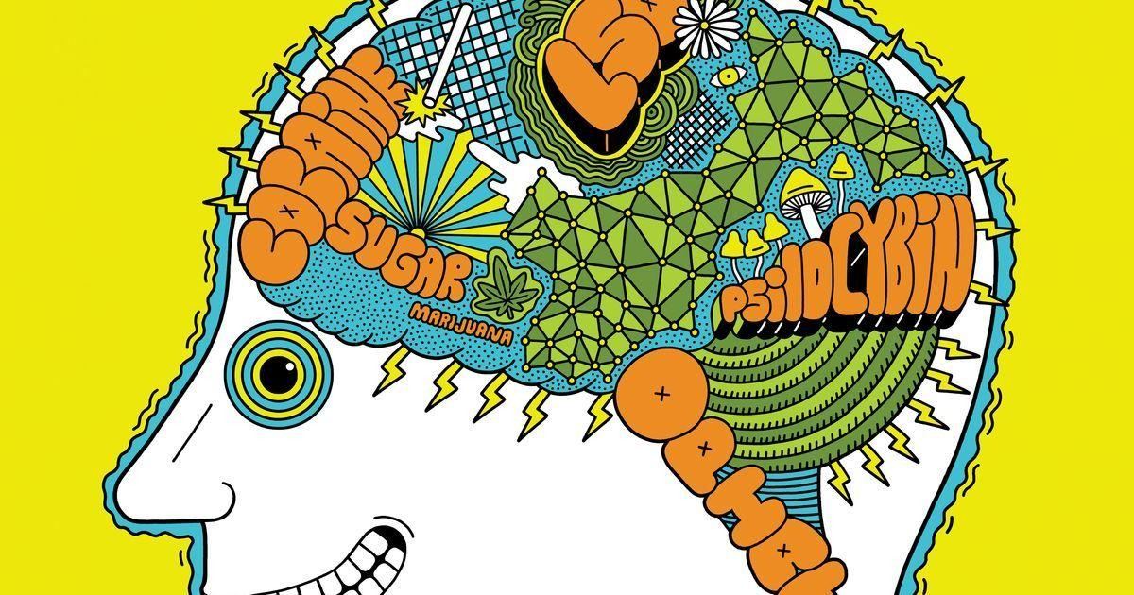

We have different kinds of drugs and each has unique functions that can be used medically; one of these drugs is called psychoactive drugs. Unfortunately, there are people who misuse and abuse drugs for their own satisfaction.

Psychoactive, also called psychotropic, is a term that is applied to chemical substances that change a person's mental state by affecting the way the brain and nervous system work.

In this activity sheet, you will learn more about the situations that a person can go through when taking psychoactive drugs. You will be guided on what decision you should make in encountering such dangerous drugs. Are you ready for a week of learning?

## Learning Competency and Code

(Analyzes situations for the use and non-use of psychoactive substances. H9S- IIb-17)

## LET US REVIEW

Put a check if the statement is a risk factor or a protective factor on the space provided after the statement.

|  |  |  |
| --- | --- | --- |
| **Statements Risk Factor Protective Factor** | | |
| **1.** Use of drugs at an early stage |  |  |
| **2.** Positive interaction with people |  |  |
| **3.** Formation of friendships |  |  |
| **4.** Feelings of isolation |  |  |
| **5.** Inconsistent family rules |  |  |
| **6.** Strong community advocacy against drugs |  |  |
| **7.** Lack of commitment to studies |  |  |
| **8.** Good to excellent academic performance |  |  |

|  |  |  |
| --- | --- | --- |
| **9.** Strong family values |  |  |
| **10.** Easy access to gateway drugs |  |  |
| **11.** Clear and consistent family rules |  |  |
| **12.** Reliance on friends for emotional support |  |  |
| **13.** Poor attendance in school |  |  |
| **14.** Positive attitude which combat drug use |  |  |
| **15.** Poor family ties |  |  |

## LET US STUDY (PAG-ARALAN MO)

Psychoactive drugs are substances that, when taken in or administered into one's system, affect mental processes, e.g. perception, consciousness, cognition or mood and emotions. Psychoactive drugs belong to a broader category of psychoactive substances that include also alcohol and nicotine

These drugs may be used recreationally to purposefully alter one's consciousness (such as coffee, alcohol or cannabis), as entheogens for spiritual purposes (such as the mescaline- containing peyote cactus or psilocybin-containing mushrooms), and also as medication (such as the use of narcotics in controlling pain, stimulants to treat narcolepsy and attention disorders, as well as anti-depressants and anti-psychotics for treating neurological and psychiatric illnesses).

Many of these substances (especially the stimulants and depressants) can be habit- forming, causing chemical dependency and may lead to substance abuse. Conversely, others (namely the psychedelics) can, in certain circumstances, help to treat and even cure such addictions.

With all of the benefits of using psychoactive drugs, there are also its negative effects especially with the developing brains of teens. These are the academic and psychosocial indicators of substance use based on a Brazilian study made about teenagers on using psychoactive drugs:

|  |  |
| --- | --- |
| **Academic Psychosocial** | |
| Impaired attention and judgment | Lying |
| Frequent absences and tardiness | Stealing |
| Dropout | Promiscuity |
| Conflict with teachers | High-risk sexual behavior |
| Suspension or expulsion from school | Conflict with teachers and other authorities |
|  | Poor-hygiene |
|  | Drug-using peers |
|  | Decreased or absent interest in extracurricular activities |
|  | Social Withdrawal |
|  | Frequent unexplained injuries |
|  | Identification with drug culture (clothing, music,  movies) |

Different people encounter various situations in using psychoactive drugs but when people start to refuse or deny using these kinds of drugs, what do you think will happen?

|  |  |  |
| --- | --- | --- |
| **Agree Disagree** | | |
| All Drugs have bad effects on people |  |  |
| People should only take psychoactive drugs based on prescription |  |  |
| You should never take drugs |  |  |

If you are in between with Agree or Disagree, defend your answer:

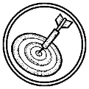

**LET US PRACTICE**

## ACTIVITY NO. 1

Give your reaction with the following statements, write your opinion, or your feelings about the statement. Use a separate piece of paper.

* 1. It is better if I drink than take drugs right?
  2. What’s the big deal? I only drink beer.
  3. What’s the difference if I start to drink now or I wait until I’m 19 – it’s only a few years difference?
  4. I only drink and smoke occasionally so what’s the problem?
  5. My parents smoke, so how can you tell me not to use drugs?

## ACTIVITY NO. 2

In the Philippines, you have to be 18 years old to smoke and drink but most of the time, this does not happen. How would you advertise to show the proper age in smoking and drinking by drawing? Draw your output on a piece of short bond paper. Give your drawing a title and an explanation of your output. Rubric for the drawing:

|  |  |  |  |
| --- | --- | --- | --- |
| Student Expectation Points Self Teacher | | | |
| Drawing matches the description and topic | **15** |  |  |
| Drawing includes many details (shapes, colors, sizes, etc.) | **20** |  |  |
| Drawing is legible, and large enough to see all details | **20** |  |  |
| Drawing has a title that helps explain the content | **10** |  |  |
| Drawing has brief statements that explains what the  drawing is about | **15** |  |  |
| Drawing is submitted on time | **20** |  |  |

## LET US REMEMBER

**ACTIVITY NO. 3**

Create a brochure about the advantages and disadvantages of using psychoactive drugs. Choose 2 psychoactive drugs and search one story (real life story) on what happens if one person abused that drug. You can search the internet but be careful of putting the content on your brochure. State your opinion about the drugs that you have chosen. You can print using the computer, draw or write by hand on a SHORT bond paper. The rubric is as follows:

|  |  |  |  |  |  |
| --- | --- | --- | --- | --- | --- |
| Category |  | 4 | 3 | 2 | 1 |
| Graphics/Pictures | | Graphics go well with the text and there is balance of text and graphics | Graphics go well with the text, but graphics are a distraction to the text | Graphics go well with the text but seems “text-heavy” | Graphics do not go with the text and appear to be randomly chosen |
| Content-Accuracy | | All facts in the brochure are accurate | 99-90% of the facts in the brochure are accurate | 89-80% of the facts in the brochure are accurate | Fewer than 80% of the facts in the brochure are  accurate |
| Attractiveness Organization | & | Brochure has exceptionally attractive formatting and well-organized information | Brochure has attractive formatting and well-organized information | Brochure has well- organized information | Brochure’s formatting and organization or materials are confusing |
| Sources | | Careful and accurate records are kept to document the source of 95-100% of the facts and graphics; are also seen in the  brochure | Careful and accurate records are kept to document the source of 94-85% of the facts and graphics; are also seen in the  brochure | Careful and accurate records are kept to document the source of 84-75% of the facts and graphics; are also seen in the  brochure | Sources are not documented accurately or are not kept on many facts and graphics |
| Punctuality Spelling | & | Has no spelling errors; submitted on time | Has 1-2 spelling  errors; submitted 1 day late from the deadline | Has 3-5 spelling  errors; submitted 2 days late from the deadline | Has 6 or more spelling errors; submitted 3 days onwards late from the deadline |

## LET US APPRECIATE ACTIVITY NO. 4

These are true to life stories. Write your reaction below the paragraph and what would you do if you were in their shoes.

## TRUE STORY: TYLER LYBERT

I chose the wrong path with drugs and alcohol and now that I am in recovery I have to deal with the choices that I made while using every day for the rest of my life. I

destroyed my family, friends and my life. I have been in jail many times, had thousands of dollars in fines, inpatient rehab, car crashes and watched my friends die. If only I had chosen not to take the first drink or drug, my life would be totally different. My advice is not to let other people make choices for you. Life is so much better without drugs and alcohol.

.

## TRUE STORY: JORDAN COLE LUNSFORD

After using heroin once, Jordan died. He was a good kid, a happy kid, a kid that was going through a rough moment and his bad choice and the company he kept that night was a recipe for his death.

Questions:

1. Why do you think people use drugs?
2. What did you learn by reading these stories?

## LET US PRACTICE MORE ACTIVITY NO. 6

This is a part of a song entitled “Breaking the Habit” by Linkin Park. You can search the whole song on this link for your reference: [https://www.youtube.com/watch?v=v2H4l9RpkwM](http://www.youtube.com/watch?v=v2H4l9RpkwM).

Clutching my cure

I tightly lock the door

I try to catch my breath again

I hurt much more than any time before I have no options left again

I don't want to be the one the battles always choose 'Cause inside I realize that I'm the one confused

Questions:

1. The song is entitled, breaking the habit, what habit would you like to remove in your life because of its bad effects?
2. What do you think a person should do if he thinks he has no options in dealing with drugs?
3. If you are facing problems in your life, what is the best thing you can do so you wouldn’t depend on any kinds of drugs?

## ACTIVITY NO. 7

Explain the editorial in your own words.

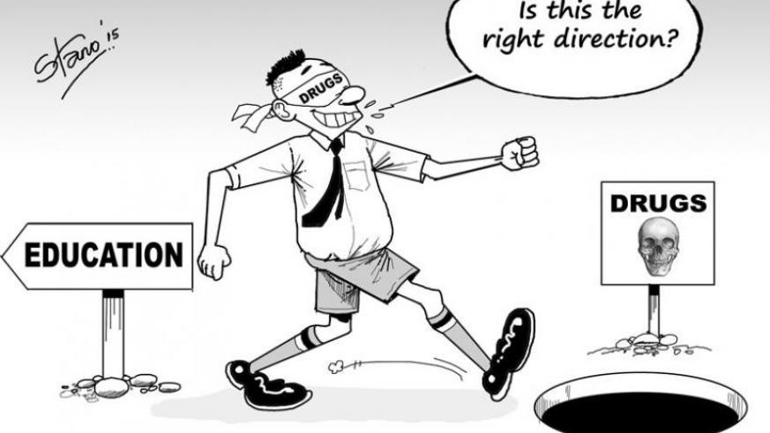

## REFLECTION

Write a letter to your future self, five (5) years from now, and put how you would face those struggles and successes in your life in that letter. You may also include how you would avoid drugs at all cost if you may.

Dear Myself,

.

Sincerely yours,

## References:

**Websites**

[https://www.who.int/health-topics/drugs-psychoactive#tab=tab_1](http://www.who.int/health-topics/drugs-psychoactive#tab%3Dtab_1) [https://www.scielo.br/scielo.php?](http://www.scielo.br/scielo.php)

script=sci_arttext&pid=S1516-44462013000500007&lng=en&tlng=en <http://mycannabisiq.ca/portfolio/questions-teens-ask-2013/>

**Picture**s [https://www.pinterest.ph/pin/291889619595135959/](http://www.pinterest.ph/pin/291889619595135959/) [https://www.newtimes.co.rw/section/read/190626](http://www.newtimes.co.rw/section/read/190626)

https://anaheimlighthouse.com/blog/43-drug-addiction-recovery-quotes-for-inspiration/

**Video** [https://www.youtube.com/watch?v=v2H4l9RpkwM](http://www.youtube.com/watch?v=v2H4l9RpkwM) Rubrics

https://zifihasywehon.parisplacestecatherine.com/how-to-write-a-tourist-brochure- rubric-15612ik.html

[https://www.pinterest.ph/pin/231583605812033979/](http://www.pinterest.ph/pin/231583605812033979/)

## Answer’s Key

Review

* + 1. Protective
  1. Protective 11. Protective

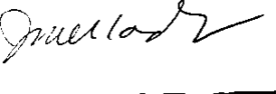Prepared by:

2. Protective

* 1. Risk

1. Protective
   1. Protective
   2. Risk
   3. Protective 13. Risk
   4. Protective 14. Protective

## JUSTINE MARIE M. COLICO

Secondary School Teacher III

5. Risk 10. Risk

1. Risk

Angeles City National High School Name of Writer





**9**

# MAPEH (HEALTH)

**Learning Activity Sheets**

Quarter 2: Week 1

**DRUGS OF ABUSE**

**Name:**

## Section:

**Grade Level:**

**Date:**

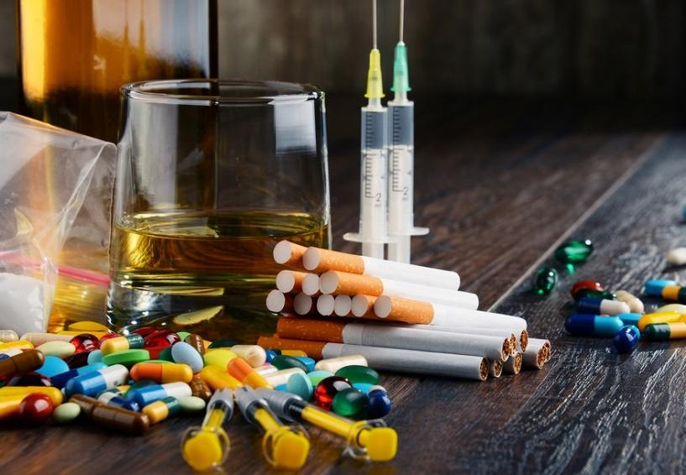

**LET US KNOW (ALAMIN MO)**

What is abuse of drugs? Does it have a harmful effect in your body? In our society, some people abuse the use of drugs not knowing that this has a harmful effect in our body.

Through the years, illegal drugs and drug addiction have been considered as one the major problems in the Philippines. We cannot deny the fact that this matter has grown immensely among our society affecting many people most especially the youth.

In this activity sheet, you will be able to classify the drugs of abuse according to their effects in the body. Stresses that some of these drugs of abuse also have their medical purposes but are highly addictive if misused and abused.

## Learning Competency and Code

Identifies the types of drugs/substance of abuse (H9S-llc-18)

 **LET US REVIEW (PAGBALIK-ARALAN MO)**

Below are the risk and protective factors in the use, misuse and abuse of drugs. Check

**RF** if it is a Risk Factor and **PF** if it is a Protective Factor.

|  |  |  |
| --- | --- | --- |
| **RF** | **PF** | **FACTORS IN THE USE OF DRUGS** |
|  |  | Good to excellent academic performance |
|  |  | Association with peers and friends known to use gateway  drugs (cigarettes and alcohol) |
|  |  | Lack of commitment to studies |
|  |  | Poor attendance in school |
|  |  | Positive interaction with people |

## LET US STUDY (PAG-ARALAN MO)

**WHAT IS DRUG?**

**Drugs** are any substances or chemicals which when taken into the body either through nasal, oral, transdermal or intravenous ways have psychological, emotional and behavioral effects on a person.

## WHAT IS DRUG OF ABUSE?

**Drugs of abuse** are drugs commonly abused by users. In the Philippines the three drugs of abuse are *shabu*, *marijuana* and *inhalants*.

## CLASSIFICATION OF DRUGS OF ABUSE

* 1. **Gateway Drugs**

A gateway drug is a habit-forming drug that can lead to the use of other, more addictive drugs. Gateway drugs such as cigarettes and alcohol are legal drugs that a non-drug user might try, which can lead him/her to more dangerous drugs such as marijuana and shabu.

## Examples of Gateway Drugs

Alcohol Marijuana Nicotine Prescription

Drugs

## Depressant Drugs

Depressant drugs slow down a person’s central nervous system. Doctors commonly prescribe depressant drugs to help certain persons to be less angry, less stressed or tensed. It makes the patients feel sleepy and light-headed. Higher doses of these drugs can cause impaired memory, judgment and coordination; paranoia and suicidal tendencies; and coma or death.

## Examples of Depressant Drugs

* + 1. **Tranquilizers –** mild effects used for anxiety
    2. **Barbiturates –** more potent depressants used for sleep disorders and seizures
    3. **Hypnotics –** the strongest of the depressants

## Stimulant Drugs

Stimulant drugs speed up a person’s central nervous system. Stimulant drugs have the opposite effect of depressants. It makes the person’s energy high. Doctors prescribe these drugs for medical purposes such as for the treatment of neurological disorder, asthma, respiratory ailments, mild depression, overweight, chronic sleep disorder, and other diseases. Negative effects of stimulants include depression and tiredness.

## Examples of Depressant Drugs

* + 1. **Cocaine –** it is powerful stimulant made from the leaves of the coca plant
    2. **Methamphetamine –** this substance strongly stimulates the central nervous system

## Narcotics

Narcotics are drugs that relieve pain and induce sleepiness. In medicine, these drugs are administered in moderation to patients with mental disorders and in those in severe pain like cancer. This drug slow down body function like breathing and heart rate **Different Types of Narcotics**

* + 1. **Opium –** Made from seedpod of the poppy plants which produces euphoric effects or unconsciousness lasting for hours
    2. **Morphine –** a widely used painkiller that is often used after surgery or for cancer cases. Small dose relieves pain while large dose induces sleep.
    3. **Heroin–** initially developed from morphine as treatment for tuberculosis and cure for morphine addiction

## Hallucinogens

Hallucinogens are drugs which distorts reality and facts. It affects all senses and makes a user see, hear and feel things that do not exist in the time being. This drug can cause sensations and make images seem real though they are not and may result in memory loss, personality changes, not performing normal activities or losing track of time and surroundings.

People use Hallucinogens by:

* Swallowing tablets or liquids - Consuming raw or dries
* Injecting - Snorting, inhaling, vaporizing or smoking

## Examples of Hallucinogens

* + 1. **Lysergic Acid Diethylamide (LSD) –** one of the most powerful mood-changing chemicals that produces tolerance. It may cause strong mood swings that range from joy to depression.
    2. **Phencyclidine, Ketamine, and Mescaline (PCD) –** these are used as anesthetic for surgery. It can be addictive and users may experience drug cravings. This drug can create delusions, paranoia, disordered thinking, and extreme anxiety.

## Inhalants

Inhalants are found in ordinary household chemical products and anesthetics. These chemicals produce vapor affecting mood behavior when inhaled. Non-medical inhalants are uncontrolled drugs. Continuous use and abuse leads to delusions, brain damage, liver damage, coma and death.

## Examples of Inhalants

|  |  |  |
| --- | --- | --- |
| **-** acetone | - rugby or solvent | -air conditioner fluid (Freon) |
| **-** ordinary and spray paint | - cleaning fluids | - gasoline |

**LET US PRACTICE (PAGSANAYAN MO)**

**ACTIVITY NO. 1**

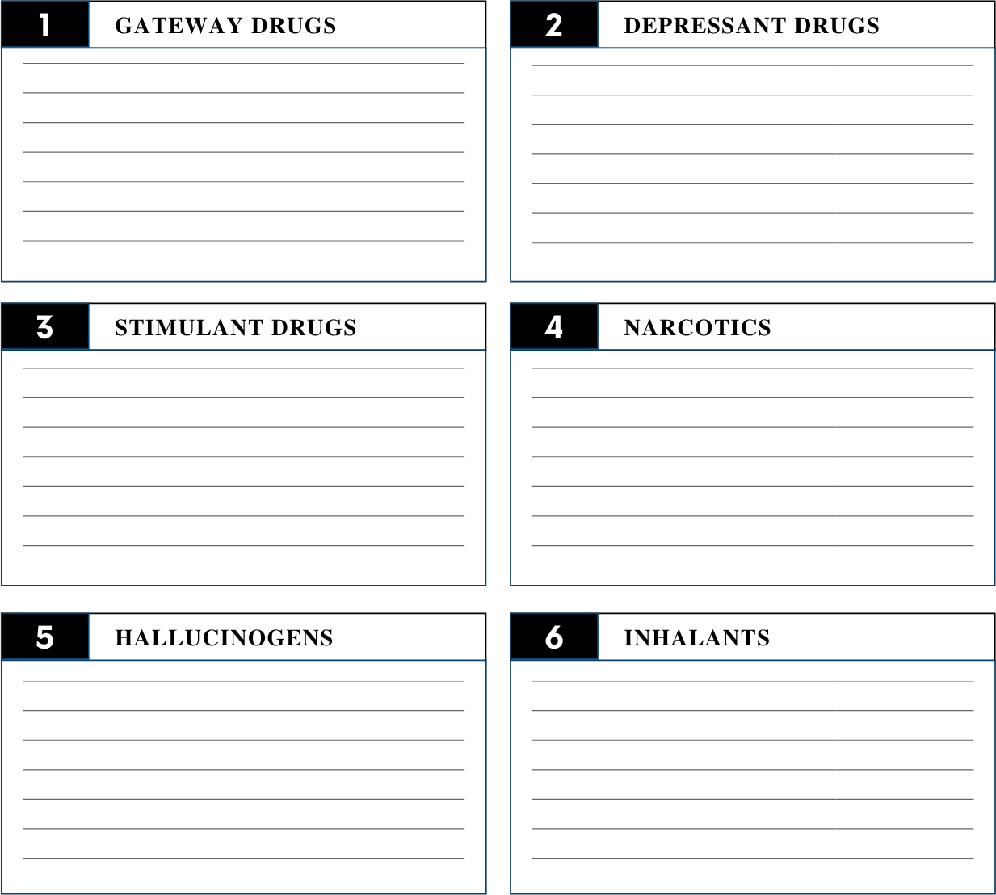Identify the harmful effects of the classification of Drugs of Abuse. Write your answer on a piece of paper.

## LET US REMEMBER (TANDAAN MO) ACTIVITY NO. 2

Copy on a piece of paper and complete the crossword puzzle below.

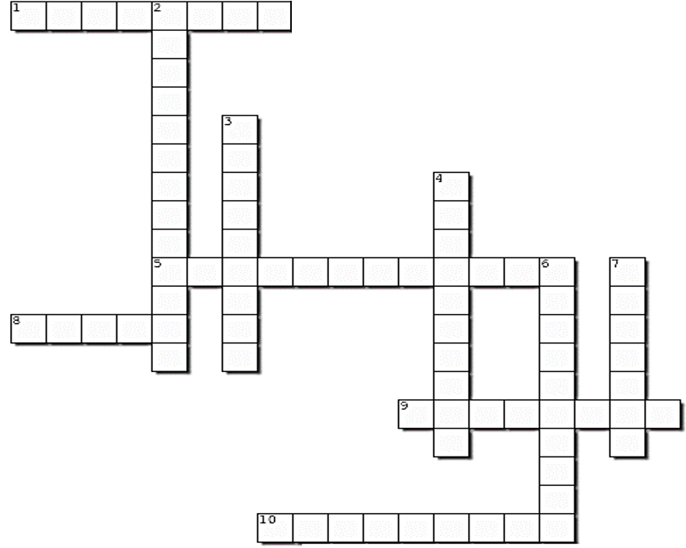

## ACROSS

1. A painkiller that is often used after surgery or for cancer cases.

5. Cigarettes and alcohol are examples of this drug.

1. An example of inhalant that can be found in air conditioners.
2. These are found in ordinary household chemical products.
3. This substance is known as 'pain killers'.

## DOWN

1. It affects all senses and makes a user see, hear or feel things that do not exist.
2. Strongest depressant
3. Doctors prescribe this drug to help certain person to be less angry or less stressed.
4. This classification of drugs speeds up the central nervous system of a person.
5. It is powerful stimulant made from the leaves of the coca plant

 **LET US APPRECIATE (ISAPUSO MO) ACTIVITY NO. 3**

Create a poster that shows the harmful effects of Abuse of Drugs in a person’s life. Make it creative and colorful. Write 3 sentences that explain the poster.

## REFLECTION

Find out how familiar you are with the different Drugs of Abuse. Answer the questions that follow. Use a separate piece of paper.

* 1. What is Drug of Abuse?
  2. As a student, what can you do to help the society to stop abuse of drugs?
  3. Through social media, how will you show other people the harmful effects of Drug Abuse?

**References:** https://qtxasset.com/styles/breakpoint_xl_880px_w/s3/fiercepharma/1553633565/FP- March%2026-Run%20April%201st-systech-primary-image-1600x1200.jpg/FP- March%2026-Run%20April%201st-systech-primary-image- 1600x1200.jpg?Hg8mtnz8zgIEcfS3dS.RfEB_BbXN50Pr&itok=fRBgSX7S [https://www.therecoveryvillage.com/wp-content/uploads/2019/09/Teen-gateway-](http://www.therecoveryvillage.com/wp-content/uploads/2019/09/Teen-gateway-) Drugs-1.png

Physical Education and Health-Grade 9 Learner’s Material, DepEd

Lacia, G. C., Hernandez, K. M., Solano, G. A., Fabella, M. G., Solis, R. V., Callo, L. F., *The 21st Century MAPEH in Action.* Philippines

## Answer’s Key Let’s Try

1. PF
2. RF
3. RF
4. RF
5. PF

## Activity No. 1

Scores may vary based on the answers

## Activity No. 2 ACROSS

1. orphine

5. ateway Drugs

1. reon
2. In lant

10 arcotics

## DOWN

1. allucinogens
2. Hypnotics
3. epressant
4. timulants
5. C aine

### *Prepared by:*

**MICELLE KHATE M. BALBERAN**

Secondary School Teacher I Angeles City National High School Name of Writer



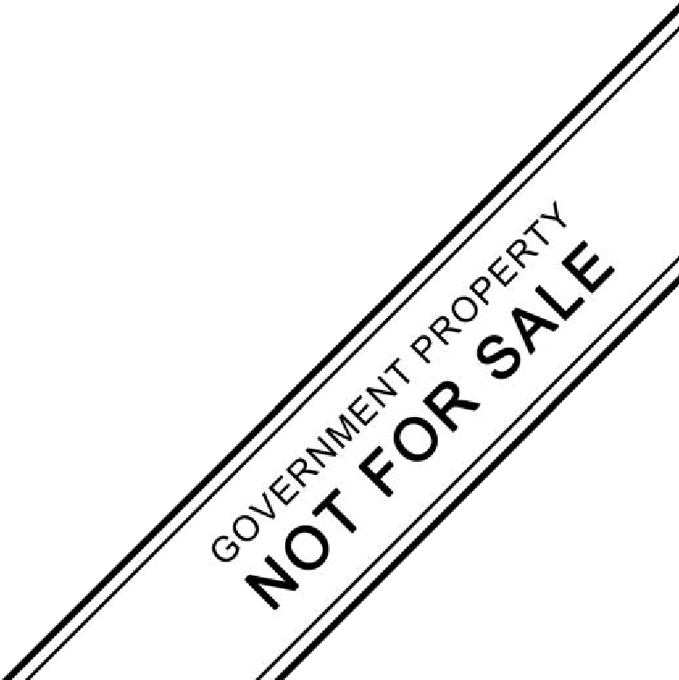

**9**

# MAPEH (HEALTH)

**Learning Activity Sheets**

Quarter 1: Week 1

**MYTHS AND MISCONCEPTIONS ABOUT**

**DRUGS OF ABUSE**

**Name:**

## Section:

**Grade Level:**

**Date :**

## LET US KNOW (ALAMIN MO)

Oftentimes, we find that people are unsure about their abilities to overcome addiction because of their perceptions of what addiction really is. These commonly accepted myths can be disheartening – but you can overcome this way of thinking by understanding the truth of recovery. Here, we’ll shed some light on some of the most common myths about drug abuse and addiction.

## LET US REVIEW (PAGBALIK-ARALAN MO)

Answer the following questions:

* 1. What do you know about drug use?
  2. Why do people use drugs?
  3. What do you mean by Euphoria?
  4. What are the effects of drug dependence?

## LET US STUDY (PAG-ARALAN MO)

**Myths and Misconceptions about Drugs of Abuse**

|  |  |
| --- | --- |
| **Myths and Misconceptions** | **Facts about Drugs of Abuse** |
| Drugs of abuse remove life’s problems and worries | Drugs of abuse are not the solution to problems and worries people encounter. Some people believe that using drugs eliminates one’s problems and worries in life. The truth is drugs of abuse will only worsen the scenario and further add more problems some of which are even harder to solve.  *Drugs of abuse worsen life’s problems and*  *worries.* |
| Drugs of abuse make a person bold and brave. | Certain drugs of abuse remove shyness and inhibition. In psychology, normal inhibition prohibits a person to do unacceptable things, thoughts and desires. Normal inhibition includes not taking other people’s things, not crossing a busy street and knowing what is right from wrong. The temporary courage brought about by taking drugs is a dangerous  one as it makes a drug user lose normal |

|  |  |
| --- | --- |
|  | judgement which is part of a person’s normal inhibition.  *Drugs of abuse place a user in a dangerous*  *and life-threatening situation.* |
| Drugs of abuse improve memory. | Drugs of abuse shut down proper brain functioning. Certain drugs stimulate the brain but do not really help improve memory. Most drug users claim they think better and clearly after taking drugs but tests on performance and cognition have proven that they performed worse.  *Drug of abuse does not improve memory.* |
| Drug of abuse heat up the body | Drug users believe that certain drugs cause the blood to become warmer which makes the body temperature rise. In cold countries, drugs are used to heat the body. The truth about this is far from reality. Drugs dilate blood vessels in the skin which makes blood flow nearer to the skin which enhances convection of heat from the body to the outside environment. Convection transfers heat from inside the body to outside. Through convection of heat, body heat is lost faster than normal.  *Drugs of abuse do not heat up the body; instead they make the body lose heat faster than normal.* |
| Drugs of abuse help in the digestion of food | Certain drugs of abuse stimulate the production of stomach acids. Constant exposure to higher than normal acid level damages stomach linings which can result in ulcers.  *Drugs of abuse do not help in the digestion of food.* |

**LET US PRACTICE ( PAGSANAYAN MO)**

**ACTIVITY 1**

**Let us try !**

**Match column A to Column B. Write the correct letter before the number. Use a separate piece of paper for your answer.**

**Column A. Column B.**

1. Drug of abuse improves a . Place a user in a dangerous and memory. life threatening situation.

2. Drugs of abuse help in b. Worsen life’s problem and worries. digestion of food.

3. Drugs of abuse heat up the body. c. Shut down the proper brain

function

4. Drugs of abuse make a person d. Drugs that makes you stronger and bold and brave. faster.

5. Drugs of abuse remove life’s e. Enhance convection of heat from the problems and worries. body to the outside environment

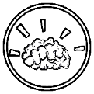f. Stimulate the production of stomach ache

## LET US REMEMBER (TANDAAN MO)

* + - Drugs of abuse do not improve memory.
    - Drugs of abuse do not help in the digestion of food.
    - Drug of abuse places a user in a dangerous and life-threatening situation.
    - Drugs of abuse worsen life’s problems and worries.
    - Drugs of abuse do not heat up the body; instead they make the body lose heat faster than normal.

## LET US APPRECIATE (ISAPUSO MO)

**You have to want drug treatment for it to be effective**. Essentially no one wants a drug treatment. People seeking a drug treatment have two primary reasons, a court

order and an urge from loved one’s. Scientific studies show that those who are highly pressured to confront and surmount addiction get better treatment regardless of the reason they sought the rehabilitation.

## Abusers can end drug use if they really want to and no treatment is needed.

Studies show that long-term drug use affects the brain making users crave more for drugs and thus make quitting harder. There is extreme difficulty for addicted persons to succeed and sustain lasting abstinence.

**Users can’t be compelled into treatment.** Treatment can be voluntary or imposed. People obliged by law into treatment and those who voluntarily seek treatment can be both successful.

**Treatment should have a standard program for everyone.** The most effective Program for rehabilitation is an individual treatment plan based on the individual’s problems. These plans should be holistic and may include combinations of medication and different therapies.

## Activity 2

Write TRUE If the statement is True, FALSE If the statement is False. Use a separate piece of paper for your answer.

1. People seeking drug treatment have two primary reasons, a court order and an urge from loved one’s.

2. Studies show that long-term drug use affects the brain making user crave more for drug and thus make quitting harder

3. The most effective Program for rehabilitation is a standard treatment based on individual problems.

4. Drug of abuse improves memory.

5. Drug of abuse removes life’s problems and worries

## LET US PRACTICE (GAWIN MO)

ACTIVITY 3: ACROSTIC POEM

Make an acrostic poem about breaking the myths and misconception about drugs.

Use the letters of the words “ DRUG STAY AWAY” as the first letters of each stanza. Use a separate piece of paper for your answer

D R U G S T A Y A W A Y

ACTIVITY 4: ADVOCACY BROCHURE

Now that you have learned the myths and misconceptions of drug use and abuse, create an advocacy brochure about drug use and abuse. Have your teacher review and approve the advocacy brochure. Produce ten copies of the advocacy brochure and distribute it to friends. Let them sign on a piece of paper as a proof of receipt and post on account.

Submit the original brochure once you returned the Activity sheet.

## REFLECTION

Check the appropriate box that corresponds to your experiences

|  |  |  |  |
| --- | --- | --- | --- |
|  | **Learning Outcomes** | **Yes** | **No** |
| 1 | I analyze the myths and misconceptions about drug of abuse. |  |  |
| 2 | I learned and understand the bad effects drug use that alter the behavior,  mental, physical and psychological condition of s drug dependence. |  |  |
| 3 | I conducted an interview online with friends about myths and misconception  of drug of use. |  |  |
| 4 | I learned that drug dependence results in drug abuse, drug tolerance,problems  with society and law, severe health problems, poor quality of life. |  |  |
| 5 | I learned that drug of abuse does not improve memory. |  |  |

## References:

MAPEH 9 – Physical Education and Health Learner’s materials pp. 294-295 [https://www.drugabuse.gov/publications/media](http://www.drugabuse.gov/publications/media-guide/science-drug-use-addiction-basics)-[guide/science](http://www.drugabuse.gov/publications/media-guide/science-drug-use-addiction-basics)-drug-[use](http://www.drugabuse.gov/publications/media-guide/science-drug-use-addiction-basics)-[addiction-basics](http://www.drugabuse.gov/publications/media-guide/science-drug-use-addiction-basics) [https://www.drugfreeworld.org/drugfacts/drugs/why](http://www.drugfreeworld.org/drugfacts/drugs/why-do-people-take-drugs.html)-do-[people](http://www.drugfreeworld.org/drugfacts/drugs/why-do-people-take-drugs.html)-[take](http://www.drugfreeworld.org/drugfacts/drugs/why-do-people-take-drugs.html)-[drugs.html](http://www.drugfreeworld.org/drugfacts/drugs/why-do-people-take-drugs.html)

[https://www.associationofinterventionspecialists.org/five](http://www.associationofinterventionspecialists.org/five-consistent-myths-about-drug-abuse-)-[consistent](http://www.associationofinterventionspecialists.org/five-consistent-myths-about-drug-abuse-)-myths-[about-drug-abuse-](http://www.associationofinterventionspecialists.org/five-consistent-myths-about-drug-abuse-) and-addiction/Picture: [www.Brainzyme.com](http://www.Brainzyme.com/) https://deserthopetreatment.com/addiction- guide/substance-abuse/myths/

## Answer’s key:

**Review**

1. Drug use refers to any scope use of illegal drugs like shabu, marijuana and inhalant or solvents.
2. People use drugs because they want to change something about their lives, some reasons:

To fit in; to escape or relax; to relieve boredom; to rebel; to experiment.

1. Euphoria is the high sensation of feeling good and extreme relaxed, a sensation brought about by chemical reactions of neurotransmitters in the brain.
2. Drug dependence is a condition in which a person become dependent on some drug to achieve physical and mental satisfaction. Either prescription drug or non- prescription.

Activity 1:

1. C
2. F
3. E
4. A
5. B

Activity 2:

1. T
2. T
3. F
4. F
5. F

Activity 3 and 4: Answers may vary

Prepared

## RENATO B. ANLOAGUE

**Teacher III**

**Angeles City National High school**

**WARNING SIGNS OF SUBSTANCE USE AND ABUSE**

Name:

Section:

 **LET US KNOW (ALAMIN MO)**

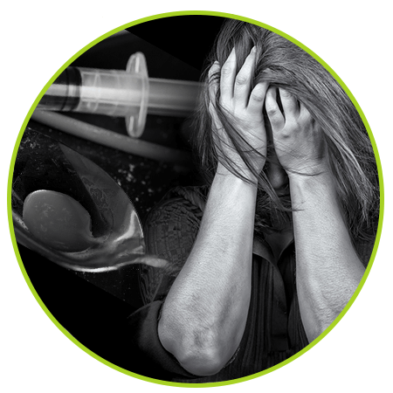It is important to know the warning signs of substance use and abuse. Alcohol or drug addiction changes the way a person looks, acts, and feels. The symptoms of substance use disorders are linked to change in the body, behavior, performance and emotions. Thankfully, you can discover when a friend or family member has become addicted to drugs by observing the following signs of substance use and abuse. This lesson will be your guide in recognizing and understanding the effects of substance use and abuse on our body.

Level:

Date:

### *Learning Competency and Code*

Recognizes Warning Signs of Substance Use and Abused (H9S-lld-20)

 **LET US REVIEW (PAGBALIK ARALAN MO)**

Answer the following questions in a piece of paper.

1. What are the warning signs and symptoms of drug abuse?
2. What are the different physical changes of a drug abuser?
3. Why do drug abuser changes in behavior?
4. What are the psychological effects of drug abuse?

## LET US STUDY (PAGARALAN MO)

Users usually neglect the effects of drugs on their body. They may just be after the immediate effect, usually the high, the energy, the relaxing effect, and others. Sometimes, the realization comes too late and to some the realization never come at all because the drugs had caused too much damaged. For the awareness of all, here are the common warning signs of substance use and abuse.

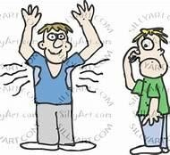

**Poor hygiene**

Lack of personal care

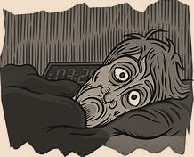

**Interrupted sleep patterns**

Sleeping too long or

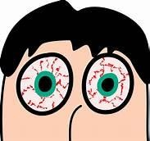

**Bloodshot eyes** Constricted pupils or redness

## Physical

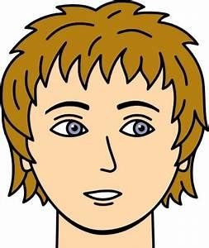

**Change in complexion** Acne, pale skin or marks

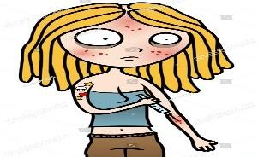

**Sudden weight loss**

Decreased appetite

**Performance**

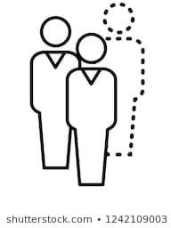

**Absenteeism** Habitual absences in school

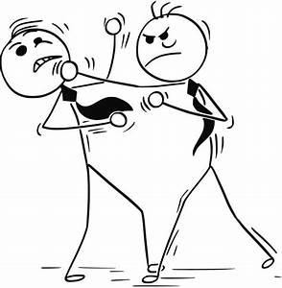

**Increased conflict**

Get into trouble

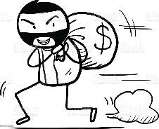

**Theft**

Stealing items or money from parents or classmates

**Psychological**

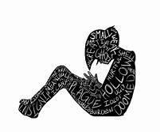

**Low self-esteem**

Lack of confidence

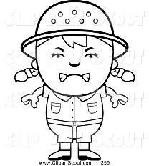

**Irritability or mood swings**

Uncontrolled temper

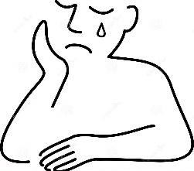

**Depression** Noticeable uneasiness

## Behavioral

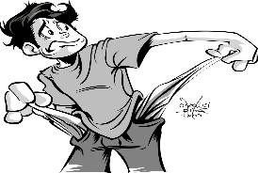

**Financial distress** Selling belongings or borrowing money

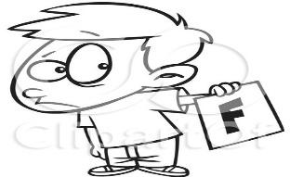

**Ignoring responsibilities** Neglect of obligations at school or in home

**LET US PRACTICE (PAGSANAYAN MO)**

**ACTIVITY 1: TRUE/ FALSE**

Directions: Write TRUE in column B if the statement/s in column A are the warning signs of drug use and abuse and FALSE if not.

|  |  |
| --- | --- |
| **COLUMN A** | **COLUMN B** |
| 1. Negative outlook in life |  |
| 2. Sudden loss of weight |  |
| 3. Interested in school activities |  |
| 4. Failing grades |  |
| 5. Extreme mood swings |  |
| 6. Ability to concentrate |  |
| 7. Reddish eyes |  |
| 8. Getting into trouble |  |
| 9. Loss of concentration |  |
| 10. Lack of confidence |  |

## LET US REMEMBER (TANDAAN MO)

Signs of substance use and abuse

### *Physical changes*

* + ***Psychological symptoms***
  + ***Changes in behavior***
  + ***Changes in performance***

**LET US APPRECIATE (ISAPUSO MO) ACTIVITY 2: LOOP-A-WORD**

Directions: Loop a word/s related to the topic and say something about the word that is loop.

|  |  |  |  |  |  |  |  |  |  |  |  |  |  |  |
| --- | --- | --- | --- | --- | --- | --- | --- | --- | --- | --- | --- | --- | --- | --- |
| A | Y | I | R | R | E | S | P | O | N | S | I | B | L | E |
| X | D | N | B | I | R | E | D | P | N | O | S | R | K | L |
| N | E | N | P | S | L | W | N | C | P | D | F | N | Q | W |
| W | P | R | A | B | S | E | N | T | E | E | I | S | M | T |
| O | R | C | P | B | A | I | T | H | C | O | P | K | R | N |
| G | E | T | P | N | P | G | Y | E | A | G | O | C | P | I |
| R | S | F | Y | I | H | H | C | F | S | N | P | R | E | S |
| P | S | T | U | D | O | T | D | T | C | B | T | L | K | Y |
| V | I | C | K | W | I | L | F | P | F | E | B | K | L | O |
| X | O | R | L | I | J | O | C | K | R | D | S | D | R | T |
| W | N | F | B | H | P | S | I | T | O | S | W | O | T | G |
| A | D | T | U | Y | R | S | M | N | L | I | X | S | K | J |

**1.**

**2.**

**3.**

**4.**

**5.**

## LET US PRACTICE (GAWIN MO)

**ACTIVITY 3: IDENTIFICATION**

Directions: Identify the given warning signs of substance use and abuse if they are ***physical***, ***behavioral***, ***psychological*** or ***performance***. Write your answer on the blank provided before the number.

1. Absenteeism

2. Neglected responsibilities

3. Bloodshot eyes

4. Hot tempered

5. Laziness

6. Changes in appearance

7. Stealing money

8. Sudden loss of weight

9. Depression

10. Uncontrolled irritation

 **REFLECTION**

1. Why do we need to know the signs of substance use and abuse?
2. How will you deal with a drug abuser?

## REFERENCES

The 21st Century MAPEH in Action Worktext in Music, Arts, Physical Education, and Health Learner’s Material for PE and Health 9

gatewayfoundation.org https://images.search.yahoo.com/

https://[www.tn.gov/behavioral-health/substance-abuse-services/treatment---](http://www.tn.gov/behavioral-health/substance-abuse-services/treatment---) recovery/treatment---recovery/prescription-for-success/warning-signs-of-drug-abuse.html https://[www.google.com/search?q=WARNING+SIGNS+OF+SUBSTANCE+USE+AND+A](http://www.google.com/search?q=WARNING%2BSIGNS%2BOF%2BSUBSTANCE%2BUSE%2BAND%2BA) BUSE&sxsrf=ALeKk02_vi6AJ_S5hasmXHdrssX_afYFPA:1599646060918&source=lnms& tbm=isch&sa=X&ved=2ahUKEwjtp- j56dvrAhU7K6YKHcaYBuoQ_AUoAXoECAsQAw&biw=1536&bih=722&dpr=1.25#imgr c=cFZjJUcvzc6YkM

## ANSWER KEY

### *Activity 1*

1. TRUE 6. FALSE
2. TRUE 7. TRUE
3. FALSE 8. TRUE
4. TRUE 9. TRUE
5. TRUE 10. TRUE

### *Activity 2*

|  |  |  |  |  |  |  |  |  |  |  |  |  |  |  |
| --- | --- | --- | --- | --- | --- | --- | --- | --- | --- | --- | --- | --- | --- | --- |
| A | Y | I | R | R | E | S | P | O | N | S | I | B | L | E |
| X | D | N | B | I | R | E | D | P | N | O | S | R | K | L |
| N | E | N | P | S | L | W | N | C | P | D | F | N | Q | W |
| W | P | R | A | B | S | E | N | T | E | E | I | S | M | T |
| O | R | C | P | B | A | I | T | H | C | O | P | K | R | N |
| G | E | T | P | N | P | G | Y | E | A | G | O | C | P | I |
| R | S | F | Y | I | H | H | C | F | S | N | P | R | E | S |
| P | S | T | U | D | O | T | D | T | C | B | T | L | K | Y |
| V | I | C | K | W | I | L | F | P | F | E | B | K | L | O |
| X | O | R | L | I | J | O | C | K | R | D | S | D | R | T |
| W | N | F | B | H | P | S | I | T | O | S | W | O | T | G |
| A | D | T | U | Y | R | S | M | N | L | I | X | S | K | J |

***Activity 3***

1. Performance 6. Physical
2. Performance 7. Performance
3. Physical 8. Physical
4. Psychological 9. Psychological
5. Performance 10. Psychological

JONATHAN B. LADOT

Angeles City National High School WRITER

**SHORT TERM AND LONG TERM EFFECTS OF SUBSTANCE USE AND ABUSE**

**Name:**

## Section:

**Grade Level:**

**Date :**

## LET US KNOW (ALAMIN MO)

**MELCs**. **Discusses the harmful short- and long-term effects of substance use and abuse on the individual, family, school, and community. H9S-IId-20, H9S-IIe-f-21**

Each classification of drugs has different short-term and long-term effects. Short term effects last for a couple of days, hours or even shorter periods while long term effects can be felt for weeks, months and even for a lifetime.

The following is an overview of the short-term and long-term effects of substance use and abuse.

**LET US REVIEW (PAGBALIK-ARALAN MO)**

**Read each statement carefully.Write T on the line before the number if the statement is TRUE and F if it is False.**

1. Stimulants, depressants, hallucinogens, narcotics and inhalants are drugs of abuse.

2. Teenagers who engage in drug use and abuse are prone to drop-out and fail in their academic performance.

3. Taking small amounts of drugs of abuse will not make a person an addict in the long run.

4.There are healthy and enjoyable things to do other than taking drugs.

5. Cigarettes and alcohol are classified under gateway drugs.

6. Narcotics are given to patients with mental problems.

7. The effects of stimulants drugs are similar to the effects of alcohol intoxication.

8. The long term effects of narcotics are; paranoid, heart attack, brain stroke, brain, kidney and liver damage, and coma which leads to death.

9. Depressants suppress or slow down the central nervous system.

10. The use and abuse of drugs can break and ignore duties and responsibilities to the family.

## LET US STUDY (PAG-ARALAN MO)

* 1. GATEWAY DRUGS

Gateway drugs are accepted and legal restrictions. In the Philippines, people below 18 years of age are not allowed to buy and use gateway drugs. The use of gateway drugs puts a person at risk of using more dangerous and illicit drugs. Tobacco of any form and alcohol are gateway drugs.

|  |  |  |
| --- | --- | --- |
| Gateway Drugs | Short-Term Effects | Long-Term Effects |
| A. Alcohol | * Slurred speech * Drowsiness * Vomiting * Diarrhea * Upset stomach * Headaches * Breathing difficulties * Distorted vision and hearing * Impaired judgment * Decreased perception and coordination * Unconsciousness * Anemia * Blackouts | * Alcohol poisoning * High blood pressure, stroke, and other heart- related diseases * Liver disease * Nerve damage * Permanent damage to the brain * Ulcers * Gastritis * Malnutrition * Cancer of the mouth and throat * Increased **risk** of stroke and * Brain damage. * Eye cataracts, * Macular degeneration * Yellowing of whites of eyes. * Loss of sense of smell and   taste |
| B. Tobacco | * Bad breath. |
|  | * Fatigue and a decrease in   energy. |
|  | * Reduction in the senses of taste and smell. |
|  | * Coughing. |
|  | * Shortness of breath. |

* 1. DEPRESSANTS

Depressants also known as “downers”, suppress or slow down the central nervous system. Depressants are also called sedatives which are used to treat anxiety, mental disorders and sleep disorders like insomnia. Different types of depressants are the following

* + 1. Tranquilizers- are mild depressants which are used to treat anxiety.
    2. Barbiturates-are stronger than tranquilizers and are used to treat insomnia and other sleep disorders and control seizures.
    3. Hypnotics-are the most powerful depressants.

|  |  |
| --- | --- |
| Short-Term Effects | Long-Term Effects |
| * Slow brain function * Slowed pulse and breathing * Lowered blood pressure * Poor concentration * Confusion * Fatigue * Dizziness * Slurred speech * Fever * Sluggishness * Visual disturbances * Dilated pupils * Disorientation, lack of coordination * Depression * Difficulty or inability to urinate * Addiction | * Chronic fatigue * Breathing difficulties * Sexual problems and sleep problems. As a dependency on the drug increases, cravings, anxiety or panic * Insomnia, weakness and nausea * For continual and high-dose users, agitation, high body temperature, delirium, hallucinations and convulsions |

* 1. STIMULANTS

Stimulants are also known as “uppers” or speeds. A person can stay awake for longer periods under the influence of stimulant drugs. Some stimulants are legal while some are illicit and dangerous. Caffeine is a stimulant which is found in soft drinks, energy drinks, coffee, tea, and chocolates. Illicit stimulants include cocaine and methamphetamine or shabu.

SHORT-TERM EFFECTS

The short-term effects of stimulants include exhaustion, apathy and depression—the “down” that follows the “up.” It is this immediate and lasting exhaustion that quickly leads the stimulant user to want the drug again. Soon he is not trying to get “high,” he is only trying to get “well”—to feel any energy at all.

LONG-TERM EFFECTS

Stimulants can be addictive. Repeated high doses of some stimulants over a short period can lead to feelings of hostility or paranoia. Such doses may also result in dangerously high body temperatures and an irregular heartbeat.

* 1. NARCOTICS

Narcotics are known as “painkillers”. They also induced sleepiness. Narcotics are administered to patients with mental problems. They are also given to cancer patients to relieve severe pain. Narcotic drugs include cocaine, heroin, and marijuana.

|  |  |
| --- | --- |
| Short-Term Effects | Long-Term Effects |
| * Drowsiness * Euphoria * Loss of appetite * Vomiting * Nausea * Muscle cramps and pains * Chills and shaking * Weight loss * Difficulty in breathing and sleeping * Inflammation of veins * Panic attacks | * Bad teeth * Inflammation of the gums * Constipation * Cold sweats * Itching * Weakening of the immune system * Coma * Respiratory (breathing) illnesses * Muscular weakness, partial paralysis * Loss of memory and intellectual performance * Introversion * Depression * Loss of appetite * Insomnia |

* 1. HALLUCINOGENS

Hallucinogens create hallucinations. Hallucinations distort what is real. Everything the person sees, hears , and feels are the opposite of reality.

|  |  |
| --- | --- |
| Short-Term Effects | Long-Term Effects |
| * Increased blood pressure, heart rate, and body temperature * Dizziness and sleeplessness * Loss of appetite, dry mouth, and sweating * Numbness, weakness, and tremors * Impulsiveness and rapid emotional shifts | * Visual disturbances * Disorganized thinking * Paranoia * Mood disturbances |

* 1. INHALANTS

Inhalants are found in common household chemical products. Inhalants are huffed and sniffed.

|  |  |
| --- | --- |
| Short-Term Effects | Long-Term Effects |
| * Slurred speech * Poor coordination * Euphoria * Dizziness and Nausea * Feeling of lightheadedness * Foul breath | * Loss of hearing * Uncontrolled muscles spasm * Brain damage * Nerve damage * Bone marrow damage |

|  |  |
| --- | --- |
| * Hallucinations * Delusions |  |

## LET US PRACTICE (PAGSANAYAN MO) ACTIVITY NO.1

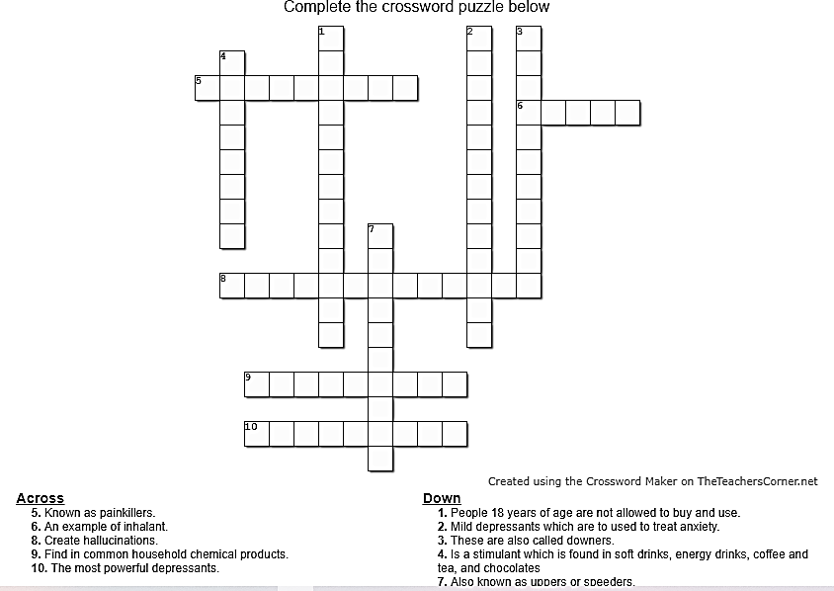

**LET US REMEMBER (TANDAAN MO) ACTIVITY NO. 2**

Match the Drug use and abuse in column A to its description in column B. Write the letter of your answer in the space provided before each number.

## A B

1. Depressants a. it is a type of narcotic drugs

2. Narcotics b. found in common household chemical product

3. Marijuana c. also known as “downers”

4. Gateway drugs d. has a long-term effect of Chronic

Obstructive Pulmonary Disease

5. Inhalants e. drugs that distort what is real

6. Stimulants f. known as “painkillers”

7. Caffeine g. has a short-term effects of mood swings

8. Hallucinogens (depression, high spirit, aggressiveness)

9. Alcohol h. this drugs are also known as “uppers” or “speeders”

10. Tobacco i. this drugs are accepted and legal with restrictions

j. a stimulant drug which found in soft drinks, energy drinks, coffee, tea and chocolate.

## LET US APPRECIATE (ISAPUSO MO) ACTIVITY NO. 3

Tell whether the given effects of drugs use and abuse is on the INDIVIDUAL, FAMILY, SCHOOL or COMMUNITY. Write your answer on the space provided before each number

1. Difficulty in maintaining personal hygiene.

2. High incidence of crime which includes stealing, robbery, and snatching.

3. Increased rate of absenteeism and tardiness.

4. Financial constraint due to drug dependence and addictions.

5. Family dishonour and embarrassment.

6. Low academic achievement rate.

7. Affected economy due to low manpower production.

8. Noticeable changes in appearance such as extreme weight loss.

9. Loss of government funds due to drug-related operations, treatment and rehabilitations.

10. Loss of interest in formerly enjoyable activities.

## LET US PRACTICE MORE (GAWIN MO) ACTIVITY NO. 4 Slogan

On a piece of paper make a slogan that encourages the youth to choose a healthy lifestyle instead of trying to use drugs. Use pencil and any colouring materials except wet colouring materials.

## Rubrics for Scoring

|  |  |  |  |  |  |
| --- | --- | --- | --- | --- | --- |
| **Criteria** | **4** | **3** | **2** | **1** | **Score** |
| **Originality** Original and clearly relate to the topic | Original, own ideas and design. Relate to the topic. The slogan looks like  professional. | Original, own ideas and design. Relate to the topic | Original but some ideas and design were from internet or others. | All ideas and design were from others and does not relate to the  topic |  |
| **Message** Memorable and says message about the  topic | Slogan is catchy, very memorable and strongly conveys the message about the topic | Slogan is memorable and does a good job of sending a message about the topic | Slogan is catchy but does not send a strong message about the topic | Slogan does not send a message at all |  |
| **Neatness** Slogan is neat and visually  appealing | Slogan is very neat and extremely visually appealing | Slogan is neat and extremely visually appealing | Slogan is neat and visually appealing | Slogan is not neat and visually appealing at all |  |
|  |  |  |  | **TOTAL** |  |

 **REFLECTION**

Answer the following questions. Write your answer on a separate sheet of paper.

1. What did you realize upon doing the activity?
2. What can you contribute to your community to put an end to the use of drugs?

## References:

**https:/**[**/www.drugfreeworld.org/drugfacts/alcohol/short-term-long-term-effects.html**](http://www.drugfreeworld.org/drugfacts/alcohol/short-term-long-term-effects.html) **https://**[**www.google.com/search?q=short+term+effects+of+tobacco&oq=short+term+eff**](http://www.google.com/search?q=short%2Bterm%2Beffects%2Bof%2Btobacco&oq=short%2Bterm%2Beff) **ects+of+tobacco&aqs=chrome..69i57j0l7.23258j0j7&sourceid=chrome&ie=UTF-8 https://**[**www.drugabuse.gov/publications/research-reports/inhalants/what-are-short-**](http://www.drugabuse.gov/publications/research-reports/inhalants/what-are-short-) **long-term-effects-inhalant-use**

**https://**[**www.medicalnewstoday.com/articles/effects-of-drug-abuse#short-term-effects**](http://www.medicalnewstoday.com/articles/effects-of-drug-abuse#short-term-effects) **https://**[**www.news-medical.net/health/What-is-Drug-Abuse.aspx**](http://www.news-medical.net/health/What-is-Drug-Abuse.aspx)

**PE and Health 9 *Learner’s Material***

## Rubrics for Essay https:/[/www.thoughtco.com/essay-rubrics-2081367](http://www.thoughtco.com/essay-rubrics-2081367)

**Answer’s Key True or False**

|  |  |  |
| --- | --- | --- |
| 1. True | 5. True | 8. False |
| 2. True | 6. True | 9. True |
| 1. True 2. True | 7.False | 10. True |

**Activity No. 1**

1. STIMULANTS 6. NARCOTICS
2. DEPRESSANTS 7. CAFFEINE
3. INHALANTS 8. TRANQUILIZERS
4. HALLUCINOGENS 9. RUGBY
5. GATEWAY DRUGS 10. HYPNOTICS

## Activity No. 2 Activity No. 3

* 1. C 1. Individual
  2. F 2. Community
  3. A 3. School
  4. I 4. Family
  5. B 5. Family
  6. H 6. School
  7. J 7. Community
  8. E 8. Individual
  9. G 9. Community
  10. D 10. Individual

### *Prepared by:*

**LAARNI P. ZAMORA SST-III**



**ROWENA M. MACASAQUIT**

SST-I

Name of Writers

**PREVENTION OF SUBSTANCE USE AND ABUSE**

Name of Learner

Section

Q2W5

Date

## Brief information for learners

Drugs are chemical substances that can change how your body and mind work. They include prescription medicines, over-the-counter medicines, alcohol, tobacco, and illegal drugs. Substance use disorders are associated with a wide range of short- and long-term health effects. Though the short- and long-term impact of drug and alcohol abuse may vary from person to person, many people struggle with the ill-effects of abusing drugs and alcohol every day

Each classification of drugs has different short-term and long-term effects. Short-term effects last for a couple of days, hours or even shorter periods while long-term effects can be felt for weeks, moths and even for a life time. The short-term effects may depend on the amount used, the potency of purity of the substance, and whether it is mixed or used in combination with any other mind-altering substances. Drugs and alcohol can affect a person’s thinking, mood, energy level, and perception.

People with addiction often have one or more associated health issues, which could include lung or heart disease, stroke, cancer, or mental health conditions. Imaging scans, chest X-rays, and blood tests can show the damaging effects of long-term drug use throughout the body.

The society and environment may affect the behaviour of someone and influence them to use different substances. There are many factors why people use and abuse different substances. These may include; peers, family, environment, stress, trauma, and low self- worth .Different substances greatly affect the person’s way of thinking. It can cause problems with memory, attention and decision-making, which make daily living more difficult. Also, can lead to depression leading to mental disorders, slow brain function which leads to temporary memory loss, brain stroke, inability to concentrate and poor judgement, depression, and brain damage.

Gateway drugs are accepted and legal with restrictions. In the Philippines, people below 18 years of age are not allowed to buy and use gateway drugs. The use of gateway drugs puts a person at risk of using more dangerous and illicit drugs. Tobacco and any form and alcohol are gateway drugs. The legality of a drug often depends on how it is being used or what it is being used for. Beyond health and relationship problems, some drug users find themselves wrapped up in legal problems. While there are many debates over whether prison is the best place for drug abusers (some believe that rehab is a wiser option). Drug use and abuse also affects the economy and community. The government loss their funds due to drug- related operations, treatment and rehabilitation. It also affects the economy because of high incidence of crime which includes stealing, robbery and snatching.

## Learning competencies

Explain the health, socio-cultural, psychological, legal, and economic scope of substance use and abuse H9S-lle-f-22

## General instructions

Dear students, we have finished our lesson regarding the substance use and abuse. If you have any questions or anything that you cannot understand about the lesson, don’t hesitate and don’t be shy to ask me. You can contact me through messenger or via text messages. I am much willing to accommodate all of your inquiries/questions. If you don’t have any questions then let’s test if you really did understand the lesson.

## Exercises/Activities

Activity 1

Interview one member of your family and asked his/her own opinion on what are the effects of substance use and abuse to the health, socio-cultural, psychological, legal and economic magnitude.

FAMILY

PSYCHOLOGICAL

SOCIO-CULTURAL

LEGAL

## Activity 2

ECONOMY

In an Oslo paper, draw a cartoon or poster that shows how drugs are a burden to health, socio-cultural, psychological, legal and economic magnitude. Use the rubrics in making your poster or drawing.

## Materials:

* + - Oslo paper
    - Oil pastel/ Crayon
    - Pencil/Pen
    - Poster paint

## Rubrics

|  |  |  |  |  |
| --- | --- | --- | --- | --- |
|  | 5 | 4 | 3 | 2 |
| Originality | Reflects an exceptional degree of student  creativity | Reflects much degree of student creativity | Reflects minimal degree of student creativity | Reflects few degree of student creativity |
| Required Elements | Includes all required elements as well as additional  information | Includes some required elements as well as additional  information | Includes few required elements as well as additional  information | Includes less required elements as well as additional  information |
| Labels | Labels clearly all items of importance | Labels clearly some items of importance | Labels clearly items of importance | Labels clearly all items of importance |

**Guide questions**

Activity 3.True or False. Write TRUE if the statement is correct, if the statement is incorrect write FALSE. Write your answer on the blank before the number.

1. In the Philippines, people below 18 years of age are not allowed to buy and use gateway drugs.

2. Drugs are chemical substances that can change how your body and mind work.

3. Short-term effects of substance can be felt for weeks, months and even for a lifetime.

4. . Substance use and abuse can cause lack of control over thoughts, feelings, ideas and behaviors.

5. Authorities are not concerned about underage smoking because it doesn’t indicate that youths are likely to break other laws.

6.Children often use drugs for the first time in the home.

7. Drug-related operations, treatment and rehabilitation are some reasons why governments lose their funds.

8. Long-term effects of substance last for a couple of days, hours or even shorter periods.

9. People abuse substances when they keep using a drug even when it causes problems in their life.

10. Selling drugs isn’t as risky for young people as it is for adults.

## Activity 4

Think of an activity in each category that helps to prevent substance use and abuse.

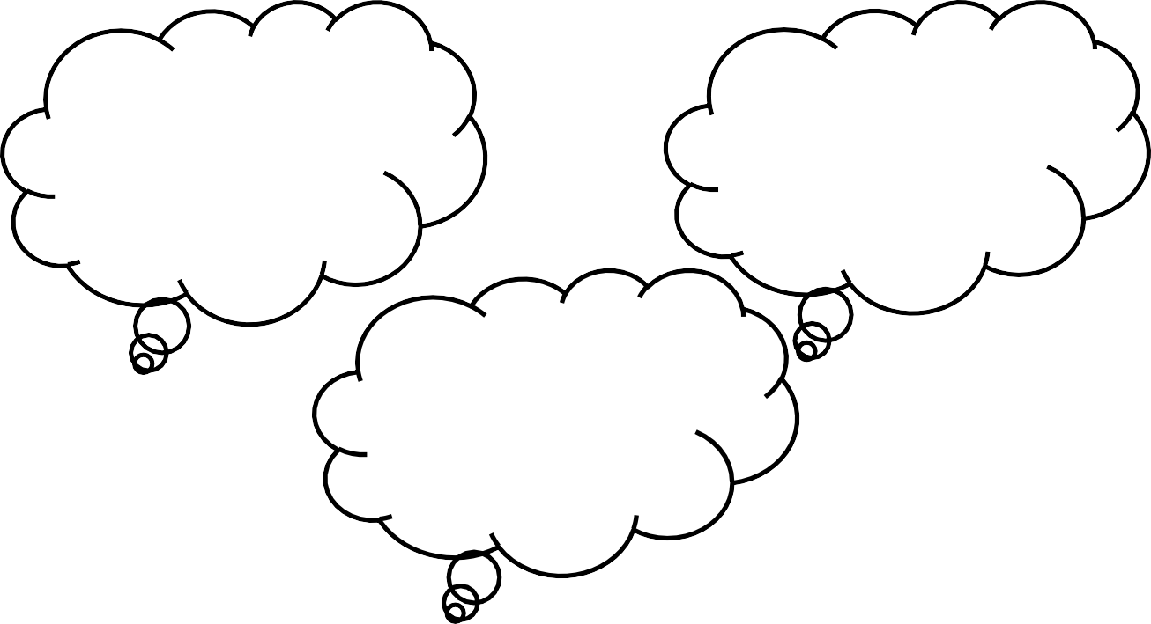

SELF

FAMILY

COMMUNITY

**Activity 4:** Complete the table, each column has a designated category; on each number write 3 effects of substance use and abuse and 3 ways on how to prevent those situations.

|  |  |  |
| --- | --- | --- |
|  | **EFFECTS OF SUBSTANCE USE AND ABUSE** | **WAYS ON HOW TO PREVENT** |
| **1.HEALTH** |  |  |
| **2.PSYCHOLOGICAL** |  |  |
| **3.LEGAL** |  |  |
| **4.SOCIO-CULTURAL** |  |  |
| **5.ECONOMIC** |  |  |

## Activity 5

In the diagram below, indicate the risk factors or reason why people use and abuse substances.

**FACTOR WHY PEOPLE USE AND ABUSE SUBSTANCES**

## Reflection

Answer the following questions:

1. How can you use your knowledge about Substance use and abuse in real life?
2. Why is knowing about Substance use and abuse important? Share your opinion.

## References Reading:

Maria Fe L. Esposo *Journey to MAPEH 9 MUSIC,ARTS,PHYSICAL EDUCATION AND*

*HEALTH* (Blk. 609 Lot 3 Phase 3,Heritage Homes Marilao, Bulacan,Philippines: KLEAFS PUBLISHING 2019) ,401-405

Jose P. Doria et. Al *Physical Education and Health Grade 9* (Philippines Published by Department Education Printed by Vibal Group Inc. 2014), 300-307

[https://www.projectknow.com/author/marisa](http://www.projectknow.com/author/marisa-crane-2)-crane-[2.](http://www.projectknow.com/author/marisa-crane-2) 2018. “The Effects of Drug Abuse.”

Project Know. November [19, 2018. https://www.projectknow.com/drug-](http://www.projectknow.com/drug-) addiction/effects/. on, Institute. 2018. “Addiction and Health.” Drugabuse.Gov. 2018.

[https://www.drugabuse.gov/publications/drugs-brains-behavior-science-](http://www.drugabuse.gov/publications/drugs-brains-behavior-science-) addiction/addiction-health.

“Gateway Foundation.” 2018. Gateway Foundation. 2018. [https://www.gatewayfoundation.org/faqs/effects-of-drug-abuse/.](http://www.gatewayfoundation.org/faqs/effects-of-drug-abuse/)

“Drug Use and Addiction.” 2019. Medlineplus.Gov. National Library of Medicine. 2019. https://medlineplus.gov/druguseandaddiction.html.

## Answer key

1.True 2.True 3.False 4.True 5.False 6.False 7.True 8.False 9.True

10. False

## PREPARED BY:

**JANNETH PAJARILLO PASIA**

Name of writer

## PREVENTION AND CONTROL OF SUBSTANCE USE AND ABUSE

**Name:**

## Section:

**Grade Level:**

**Date :**

## WHAT TO KNOW

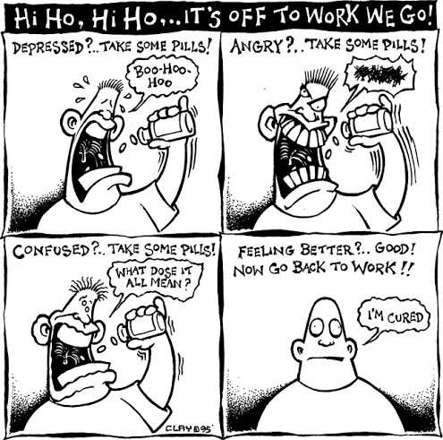Discusses strategies in the prevention and control of substance use and abuse (H9S-IIe-f-23)

What does the illustration above show? Did you feel stressed, confused, depressed or angry nowadays? How did you manage it? Who are the people that help you to feel better?

There are strategies including application of decision-making skills and the use of resistance skills in different situations related to substance use and abuse. Decision-making and resistance skills will help you enhance your knowledge, skills and attitude in facing and overcoming real-life situations. You will practice these skills in class and will be guided by your teacher. You will also suggest healthy alternatives to prevent the use of drugs of abuse.

In this activity sheet it will deal with different strategies in the prevention and control of substance use and abuse. You will practice these skills in class and will be guided by your teacher. You will also suggest healthy alternatives to prevent the use of drugs of abuse.

 **LET US REVIEW**

### *Roll Out!*

Read and understand carefully. Write **F** if it is the effects of drug use and abuse on the family, **S** if it is school, and **C** if it is community. Write your answer on the space provided.

1. Low academic achievement rate

2. Ignored duties and responsibilities

3. Affected economy due to low manpower production

4. High incidence of crime which includes stealing, robbery and snatching

5. Increased rate of absenteeism and tardiness

 **LET US STUDY WHAT IS DRUGS?**

Drugs by nature are good. They are used to treat illnesses, help calm down patients with mental disorders or relieve pain and suffering. Illicit use of drugs is the result of greediness in some men to earn money and create chaos and disorder in society. In the Philippines, the most commonly used drugs are shabu, marijuana and inhalants or solvents.

Drugs are any substances or chemicals which when taken into the body either through nasal, oral, transdermal or intravenous ways have psychological, emotional and behavioural effects on a person.

## WHAT IS PREVENTION?

Prevention is the best way for people like you to avoid the use and abuse of drugs. There are various and healthy ways to get rid of drugs. These range from simple immersion to hobbies like interactive and board games, sports, and joining clubs of interest.

## PREVENTION OF SUBSTANCE USE AND ABUSE

✔ Loving and caring family

✔ Involvement in sports

✔ Development of talents and skills

✔ A sense of worthiness and achievement

✔ Positive outlook in life

✔ Positive self-image

✔ Caring and supportive friends

✔ Always having the right attitude

✔ Ability to cope with stress and depression

✔ Having responsible adult role models

✔ Active participation in sports or recreation

✔ Participation in school clubs and activities

✔ Consultation with responsible adults like parents, teachers, counsellors regarding

problems, concerns and queries in life

## LET US PRACTICE

**ACTIVITY NO. 1**

Write **check (✓)** if the statement helps in preventing the use of substance or drugs and

**wrong ( X )** if the statement doesn’t help.

1. Going to church

2. Watching movies with family

3. Spending a lot of time on social media

4. Helping front liners

5. Involving in an art workshop

 **LET US REMEMBER ACTIVITY NO. 2**

Choose 2 Protective Factors you need to fight drug use and abuse. Explain and

relate them in real-life situations. Write your answer on a separate sheet of paper

* 1. Positive self-image and outlook in life
  2. Coping with stress and consulting with the responsible adults
  3. Development of talents and skills and having the right attitude
  4. Being a responsible adult role models and with a sense of worthiness and achievement
  5. Active participation in recreational activities and participation in school clubs or activities

 **LET US APPRECIATE ACTIVITY NO. 3**

Complete the table by thinking and stating an advocacy that could help in the

prevention of the use of substance or drugs.

|  |  |
| --- | --- |
| **As a ….** | **Advocacy** |
| **Child** |  |
| **Student** |  |
| **Member of society** |  |

## LET US PRACTICE MORE

**ACTIVITY NO. 4**

Using the fishbone diagram, cite some possible effects of not practicing the preventive ways in avoiding the use of substance or drugs.

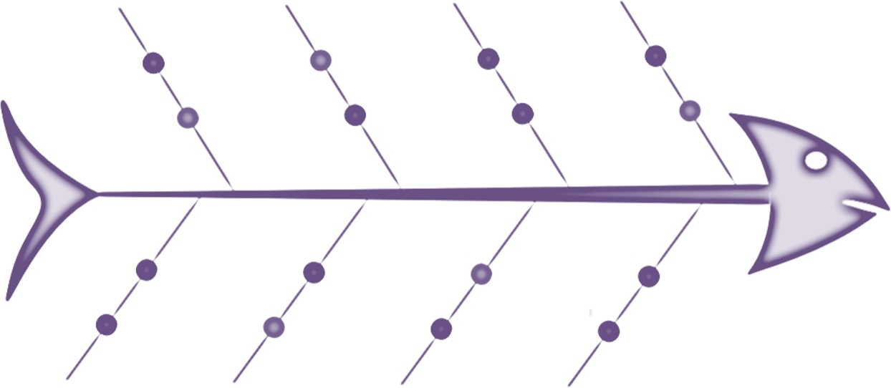The first bone was already done for you.

## REFLECTION

Compose a letter intended for the next generation. The letter must contain friendly advice on how and why we need to treasure life and what are the possible effects if they attempt to use illegal substances or drugs.

## References:

Physical Education and Health Learners Module

## Comic Cartoon Picture

Hi-Ho, Hi-Ho, It’s Off To Work We Go, “Sidewalk Bubblegum Political Comic Cartoon Strip” <http://www.sidewalkbubblegum.com/category/comics-about-the-war-on-drugs-and-> drug-culture/

## Fish Bone Diagram Picture

https://[www.edrawsoft.com/template-node-fishbone-diagram.html](http://www.edrawsoft.com/template-node-fishbone-diagram.html)

## Answer’s Key Roll Out

1. S 4. C
2. F 5. S
3. C

## Activity No. 1

1. **(✓)** 4. **(✓)**

2. **(✓) 5. (✓)**

*3.* ***( X)***

## Activity No. 2

### *It depends on the answer of the student*

**Activity 3**

***It depends on the answer of the student***

**Activity No. 4**

***It depends on the answer of the student***

**Reflection:**

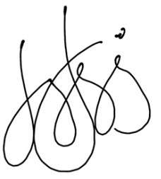**It depends on the learner’s standing (Self-assessment).**

***Prepared by:***

**Dave Apple V. Gutierrez**

SST I / CMRICTHS

Name of Writer

## HEALTY ALTERNATIVES TO SUBSTANCE USE AND ABUSE

Name: Section:

Grade level: Date:

### *Brief discussion of the lesson*

There are various and healthy ways to get rid of drugs. These range from simple immersion to hobbies like interactive and board games, sports, and joining clubs of interest.

Prevention is the best way for people like you to avoid the use and abuse of drugs. People should understand the different protective factors and risk factors. Protective factors should be enhanced while risk factors should be avoided and dropped for good. You should learn decision-making skills and resistance skills in order to be able to refuse temptations and offers from known drug users.

The following are protective factors you need to fight drug use and abuse:

* Loving and caring family
* Involvement in sports
* Positive outlook in life
* Positive self-image
* Caring and supportive friends
* A sense of worthiness and achievement
* Always having the right attitude
* Ability to cope with stress and depression
* Having responsible adult role models
* Active participation in sports or recreation
* Participation in school clubs and activities
* Consultation with responsible adults like parents, teachers, counselors regarding problems, concerns and queries in life
* Development of talents and skills

With the continuous presence of drugs in our society, the government along with non- governmental organizations and private institutions find alternative ways to prevent and control the spread of drug addiction and dependence in the country. These healthy alternatives are effective strategies to educate, advocate and promote a drug free-community

and instill in our youth that drugs are not good and will only destroy their lives and that their family and community.

### *Competency and Code*

Suggests healthy alternatives to substance use and abuse **(H9S-IIg-h24)**

## ACTIVITY 1: Alternative to substance use and abuse

There are various and healthy ways to get rid of drugs. On the boxes below there are alternatives to substance use and abuse. Each topic written on the boxes, paste one (1) picture about it. You can use an old magazine or newspaper at your home. Do the activity on a long bond paper.

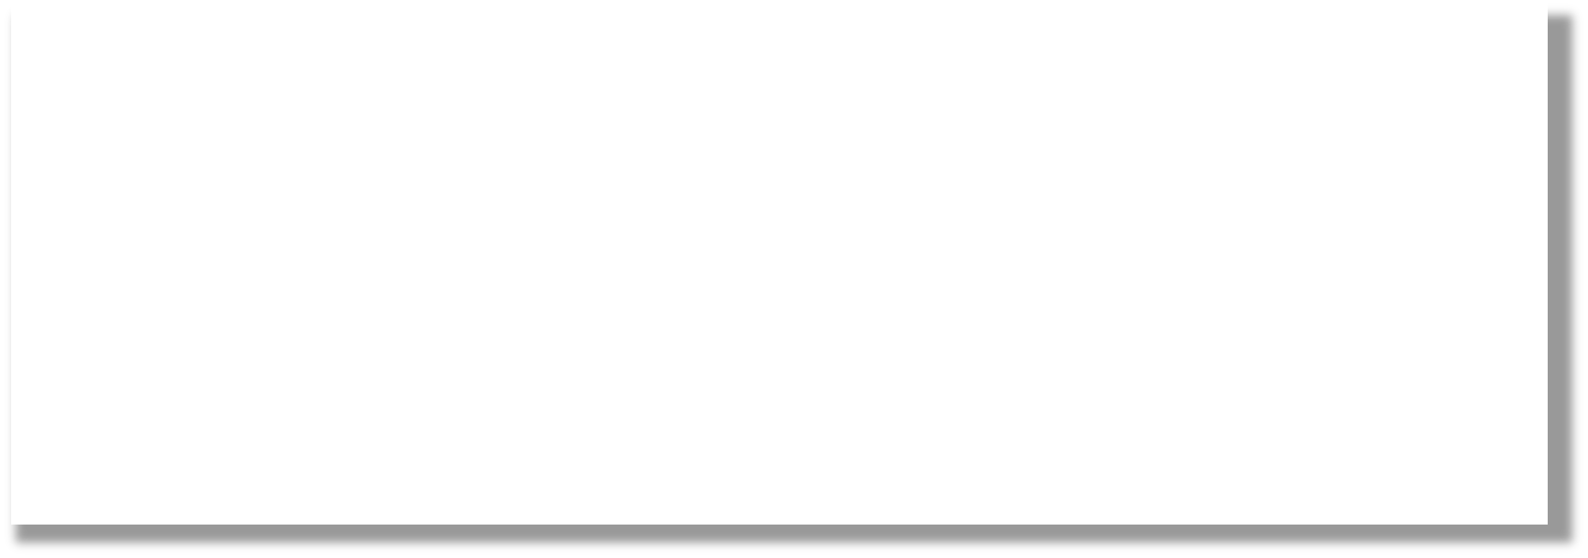

**SPORTS**

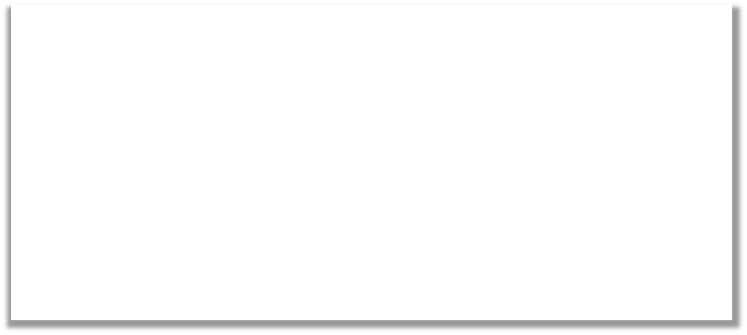

**HOBBIES PROGRAMS**

## ACTIVITY 2: POSTER MAKING

Materials needed:

* 1. Oslo Paper
  2. Pencil
  3. Crayons/Coloring Materials Procedures:

1. Look and Observe the example photo below.
2. In your Oslo paper, draw a poster about how to prevent drugs or alternatives to substance use and abuse.
3. Use your coloring materials to make your poster more appealing.

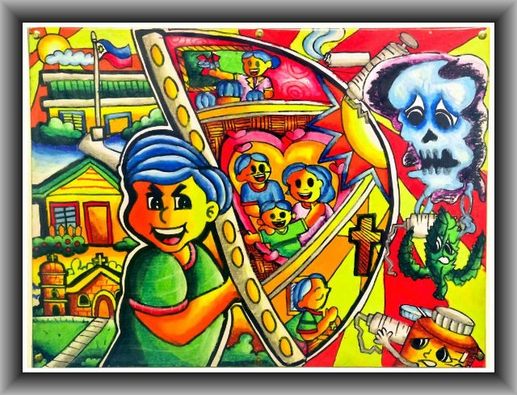

|  |  |
| --- | --- |
| **RUBRICS**  NEATNESS. THE WORK IS CLEAN | - 30% |
| RELEVANCE TO THE TOPIC | - 40% |
| DIRECTIONS AND PROCEDURES ARE FOLLOWED | - 30% |
| Total | - 100% |

## ACTIVITY 3: Acrostic Poem

Make an acrostic poem about the healthy alternative ways to prevent and control drugs. Use the letters of the words “HEALTHY WAYS” as the first letter of each stanza. Write your answer on a one whole sheet of paper.

H

E

|  |  |
| --- | --- |
| A |  |
| L |  |
| T |  |
| H |  |
| Y |  |
| W A |  |
| Y |  |
| S |  |

## Rubric for scoring:

|  |  |  |  |
| --- | --- | --- | --- |
| Structure and Format | **1**  The poem does not have a clear topic.  More than 2 lines do not start with a letter in the topic word.  More than 2 lines do not describe or relate to the topic of the poem. | **2**  The poem has a topic, but  1-2 line(s) of the poem does/do not start with a letter in the topic word.  1-2 lines of the poem does/do not describe or relate to the topic of the poem. | **3**  The poem has a clear topic. Each line of the poem begins with a letter in the topic word. Each line describes or relates to the topic of the poem. |
| Creativity | **1**  The poem does not contain any interesting word choice, vivid language, or poetic elements or techniques. | **2**  The poem contains a couple of interesting word choices, uses some vivid language, and makes use of only one poetic element or technique. | **3**  The poem contains more than two interesting word choices, uses vivid/descriptive language throughout the entire poem, and makes use of more than 1 poetic element or technique. |
| Mechanics | **1**  The poem contains 3 or more spelling, grammatical, or punctuation errors. | **2**  The poem contains 1-2 spelling, grammatical, or punctuation errors. | **3**  The poem does not contain any spelling, grammatical, or punctuation errors. |
| Legibility | **1**  Writing is not legible and the paper is messy. | **2**  Writing is not legible in some places. | **3**  Writing is legible, and the paper is neat. |

**ACTIVITY 4: SLOGAN MAKING**

Materials needed:

1. Oslo Paper
2. Pencil
3. Crayons/Coloring Materials Procedures:
   1. Look and Observe the example photo below.
   2. In your Oslo paper, make your OWN slogan about how to prevent drugs or alternatives to substance use and abuse.
   3. Use your coloring materials to make your poster more appealing.

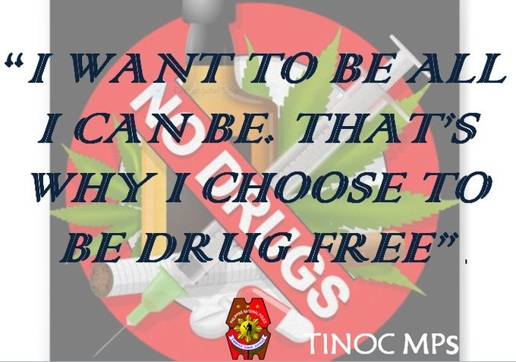

|  |  |
| --- | --- |
| **RUBRICS**  NEATNESS. THE WORK IS CLEAN | - 30% |
| RELEVANCE TO THE TOPIC | - 40% |
| DIRECTIONS AND PROCEDURES ARE FOLLOWED | - 30% |
| Total | - 100% |

### *Reflections : Based on your understanding of the lesson, answer the following* questions. Use a separate piece of paper for your answer.

1. If you know someone suffering on using substance use and abuse, what help or advise can you give to them?
2. Explain the importance of doing the healthy alternatives to substance use and abuse.

### *References:*

https://[www.depednegor.net/uploads/8/3/5/2/8352879/health_9_lm_draft_3.24.2014.pdf](http://www.depednegor.net/uploads/8/3/5/2/8352879/health_9_lm_draft_3.24.2014.pdf)

https://[www.gmanetwork.com/news/cbb/content/285313/ncmh-spearheads-campaign-](http://www.gmanetwork.com/news/cbb/content/285313/ncmh-spearheads-campaign-) against-drug-abuse/story/

https://[www.rcampus.com/rubricshowc.cfm?code=N2AC64](http://www.rcampus.com/rubricshowc.cfm?code=N2AC64) https://twitter.com/PNPIfugaoTinoc/status/810315942689460224/photo/1

### *Key to Answers:*

Activity1: No definite answer Activity2: No definite answer Activity3: No definite answer Activity 4: No definite answer

### *PREPARED BY:*

**REGGIE T. RODRIGUEZ JR.**

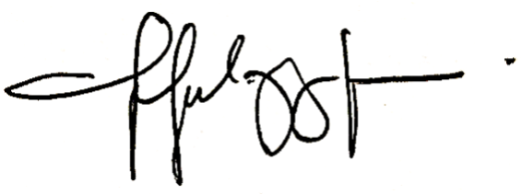

***WRITER***

**PREVENTION AND CONTROL OF SUBSTANCE USE AND ABUSE**

**Name:**

## Section:

**WHAT TO KNOW:**

**Grade Level:**

**Date :**

Applies decision-making and resistance skills to prevent substance use and abuse.

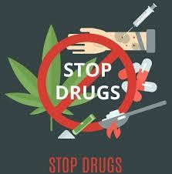H9S-IIg-h-24

This lesson deals with different strategies in the prevention and control of substance use and abuse. These strategies include application of decision-making skills and the use of resistance skills in different situations related to substance use and abuse. Decision-making and resistance skills will help you enhance your knowledge, skills and attitude in facing and overcoming real-life situations. You will also suggest healthy alternatives to prevent the use of drugs of abuse.

## LET US REVIEW(PAGBALIK-ARALAN MO)



✔ Look at the pictures below. What can you say about the pictures? Write your answer on a separate sheet of paper.

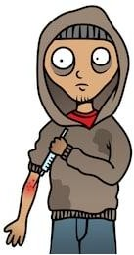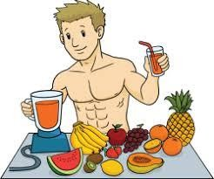Picture A Picture B

## LET US STUDY (PAG-ARALAN MO)

**HOW TO HAVE A GOOD DECISION MAKING?**

**The seven-step strategy is:**

1. Create a constructive environment.
2. Investigate the situation in detail.
3. Generate good alternatives.
4. Explore your options.
5. Select the best solution.
6. Evaluate your plan.
7. Communicate your decision, and take action.

**WHAT IS RESISTANCE?**

*Noun*

* the refusal to accept or comply with something; the attempt to prevent something by action or argument.
* the ability not to be affected by something, especially adversely. Similar:

opposition to hostility to aversion to refusal to accept

unwillingness to accept disinclination to accept reluctance to accept lack of enthusiasm for

Opposite:

acceptance

receptivity

**READING TIME!**

There are various and healthy ways to get rid of drugs. These range from simple immersion to hobbies like interactive and board games, sports, and joining clubs of interest. Prevention is the best way for people like you to avoid the use and abuse of drugs. People should understand the different protective factors and risk factors.

Protective factors should be enhanced while risk factors should be avoided and dropped for good. You should learn decision-making skills and resistance skills in order to be able to refuse temptations and offers from known drug users.

The following are protective factors you need to fight drug use and abuse:

✔ Loving and caring family.

✔ Involvement in sports

✔ Positive outlook in life

✔ Positive self-image

✔ Caring and supportive friends

✔ A sense of worthless and achievement

✔ Always having the right attitude

✔ Ability to cope with stress and depression

✔ Having responsible adult role models

✔ Active participation in sports or recreation

✔ Participation in school clubs and activities

✔ Consultation with responsible adults like parents, teachers, counsellors, regarding

problems, concerns and queries in life

Development of talents and skills



✔

## LET US PRACTICE (PAGSANAYAN MO)

The learners will list 10 alternative ways to prevent and control drug use and abuse.

Let them bring pieces of paper on which to write down specific programs and activities which can prevent and control drug use and abuse. Write your answer on a separate sheet of paper.

1. .

2. .

3. .

4. .

5. .

6. .

7. .

8. .

9. .

10. .

## LET US REMEMBER (TANDAAN MO)

The following activities will strengthen your decision-making skills. Write your answer in one whole sheet of paper. Don’t forget to write your name and section. After you answer, Attach your paper inside your learning activity sheet. (5pts.each)

DECISION-MAKING SKILLS

|  |  |
| --- | --- |
| Skills | Guides |
| **Step 1: Describe the situation**  **you are in.** | Describe the situation you are in. You can better describe  by writing it on a piece of paper. |
| **Step 2: List possible actions for the situation.** | List down all possible actions. Don’t worry about listing the not-so-good ones. You can eliminate them afterwards.  Think over them several times. |
| **Step 3: Share your list with responsible adults.** | Share your list of possible actions with a responsible adult at your home. Make sure that this person has not been associated with known drug users. His/her decisions  should be credible. |
| **Step 4: Choose which action is most responsible and suitable.** | In your own idea and answer, think of all possible actions that will protect and promote healthy results. After questioning and evaluating all actions, choose the most  responsible and suitable action for the situation. |

RESISTANCE SKILLS

Use the following steps to practice resistance skills in saying “NO” to drugs.

**Step 1:** What is the problem?

* Say what is wrong or Say that this is wrong “Drugs are against the law and school rules.”

**Step 2:** What could happen?

Answer the following: Write your answer on a separate sheet of paper.

* + Could anyone be harmed if I do it? How?
  + Could it get you into trouble? What trouble?
  + Would it make you feel bad if you do it?

**Step 3:** What are the ways of saying no? Give at least 5 examples.

## LET US APPRECIATE (ISAPUSO MO)

**ARMOR SHIELD : In a short bond paper.** Create your very own armor shield against drug use, abuse and dependence. Simple drawings will be enough. Your armor

shield will look like an emblem. Emblem means an object or the figure of an object symbolizing and suggesting another object or an idea. (20pts)

## LET US PRACTICE MORE (GAWIN MO)

WHAT WILL YOU DO?

Write your answer in one whole sheet of paper. Apply decision-making and resistance skills to the following situations. Analyze and critique your decisions and resistance.

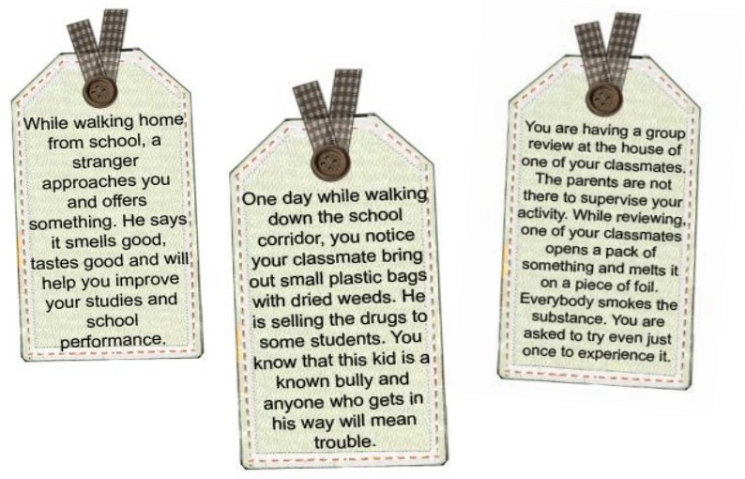

**1.**

**2.**

**3.**

References: ht[tps://www.google.com/search?q=how+to+have+a+good+decision+making&source=lmns](http://www.google.com/search?q=how%2Bto%2Bhave%2Ba%2Bgood%2Bdecision%2Bmaking&source=lmns) https://[www.google.com/search?bih=524&biw=1242&rlz=1C1CHBD_enPH810PH810&hl=](http://www.google.com/search?bih=524&biw=1242&rlz=1C1CHBD_enPH810PH810&hl)

Learner’s Material (Physical Education and Health) pages. 309-311

### *Answers: It depends on the learner’s standing (Self-assessment).*

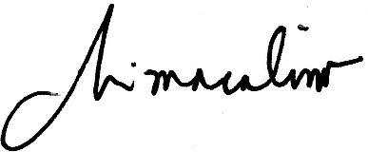***Prepared by:***

**MARJORIE I. MACALINO**

Teacher 1 Sto.Domingo Integrated School

Name of Writer